Spring Framework

Spring Tutorials

Spring is a replacement of EJB. It is created by Rod Johnson and owned by Spring Company.

Initial name of Spring was interface 21.

Spring has 2 features

1. Lightweight
2. Loosely Coupled

Suppose 2 classes are there namely A and B. If we create B class instance directly into A class, then two classes will become tightly coupled. And in future we won’t be able to upgrade from B class to C class. So, to overcome this problem we can go with interface model.

I -----> B I -----> C

Instead of creating this B class instance directly we can use the java RTP for this.

I obj = new B();

I obj = new C();

This object we are passing directly we can pass with the help of the xml model/annotations, that thing is basically called as Inversion of Control.

Spring recommends us to use association instead of inheritance.

By using runtime polymorphism and association they implemented Spring.

1. RTP
2. HAS A

To pass the runtime argument carrying the object to be replaced in the Interface model we can use Reflection class.

Else we need to have container support to carry it forward.

**IOC – 1. Core Container 2. J2EE Container**

**Spring MVC – 1. Web Container**

This web container is built on the top of IOC only.

These containers main job is to read data from xml and pass it to the POJO classes.

Core Container – BeanFactory(I)

J2EE Container – ApplicationContext(I)

Web Container – WebApplicationContext(I)

What is a container actually ?

Tomcat Container

1. Read web.xml
2. Configure servlet config and context objects. Find load on start-up servlet.
3. If load on start-up servlet is found create the object. (Basically the lifecycle methods like init , service and destroy).

Tomcat Container

1. Read xml file.
2. Create instances of xml beans.
3. Manage the lifecycle of bean classes.
4. Dynamic parameters supplies to bean claases.

IOC Container

1. Read xml file.
2. Create the object of POJO class.
3. Manage the lifecycle of the POJO classes.
4. Dynamic inputs you can pass from xml to POJO classes. This is nothing but the dependency injection.

** Dependency Injection is the main asset of the IOC container.Just passing data from the xml file to the POJO classes.

Tomcat container we are switching on and off with the help of a button. Start and Stop button.

On the contrary IOC containers offers with some interface. Now how to start and stop an interface ?

We need to have implementations of those interfaces.

BeanFactory(I) --> XmlBeanFactory

ApplicationContext(I) --> ConfigurableApplicationContext(I) --> ClassPathApplicationContext

WebApplicationContext(I) --> Factory class is given named as WebApplicationContextUtil like DriverManager class.

To Start a class we need a main method in our case it is the DriverClass.

Class Test{

public static void main(String args[]){

new XmlBeanFactory();

new ClassPathApplicationContext();

WebApplicationContextUtil.getObject(); //This method will give webapplication context

}

}

So to start a application we need a DriverClass.

So for the servlet application container class is the Driver class.

Note :

In case at start-up you want to start your Spring container you need to write code in Spring init method. For each user request we have to write code in service method.

Main required components for Spring Application

1. POJO class
2. Xml file
3. Driver class

**POJO class**

Class Test{

public static hello(){

System.out.println(“Hello World”);

}

}

**Xml file (Spring.xml)**

dtd or xsd spring-beans.jar(org.springframework.core.factory.xml.spring-beans-2.0.dtd)

<beans>

<bean class=”Test” id=”t”/>

</beans>

**Driver Class**

Class Client{

public static void main(String args[]){

Resource r = new classPathResource(“spring.xml”);

BeanFactory factory = new XmlBeanFactory(r);

// Create test class Object

Test t = factory.getBean(“t”);

Note : Make this class a singleton , if we call this object multiple time also then also one object will be created , and same object will be assigned to all.

t.hello();

}

}

IOC factory is creating only one singleton object and same object is returned to all the users.

This scope is singleton by default and can be changed accordingly.

Singleton=true/false

Scope= singleton/prototype

<bean class=”Test” id=”t” scope=”prototype”/>

Scope singleton == Then for multiple user request it will create one single object.

Scope prototype == Then for multiple user request new object is created for every request.

**Setting up a Spring Project Manually**

Step 1. Download Tomcat and set it up.

Step 2. Download Eclipse and set it up.

Step 3. Download the spring jars ,Choose the latest release and download the dist.zip <https://repo.spring.io/release/org/springframework/spring/>

Step 4. Create a Java project.

Step 5. Create a folder lib and copy all the spring jars from the libs folder of downloaded jars.

Step 6. Add the jars to the project classpath by adding the jars to the Libraries , Add jars.

**Inversion of Control-XML Conf**

Inversion of Control

Basically the design process of externalizing/outsourcing the construction and management of the object.That outsourcing is handled by Object factory.

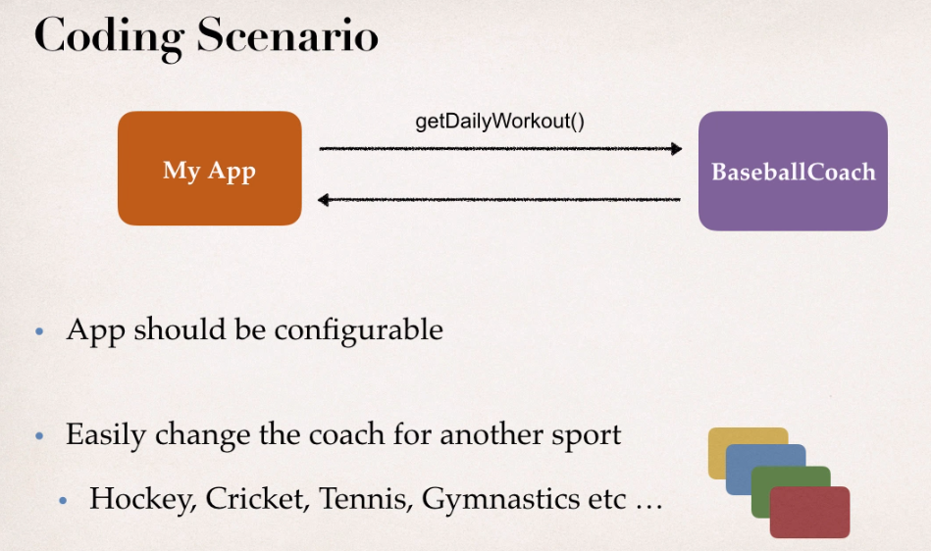

Support for configuration of the object like to passed in the run time such support is provided by object factory.

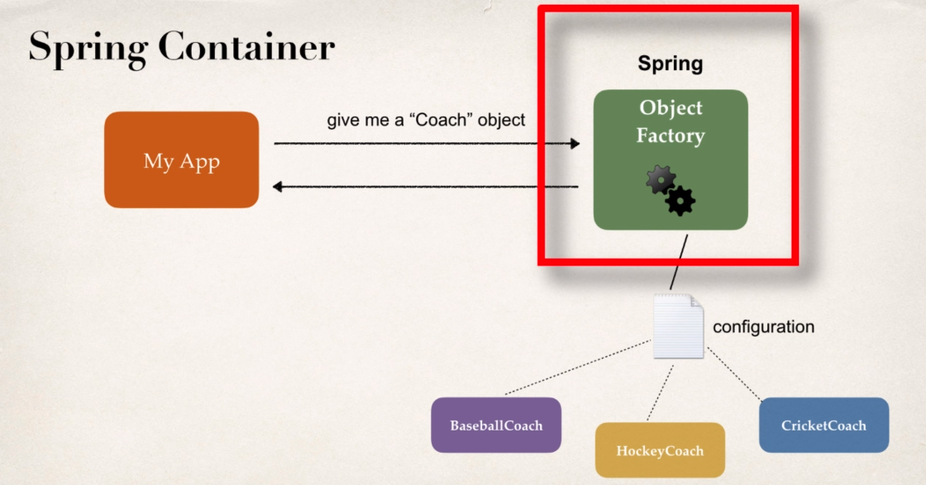

Spring provides with ObjectFactory , such that it provides with the required object based on the configuration or annotations.

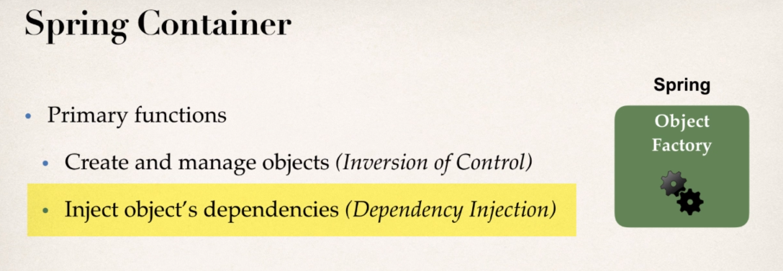

Configuring Spring Container

1. XML Configuration file (legacy, but most legacy apps still use this).
2. Java Annotations (modern).
3. Java Source Code (modern).

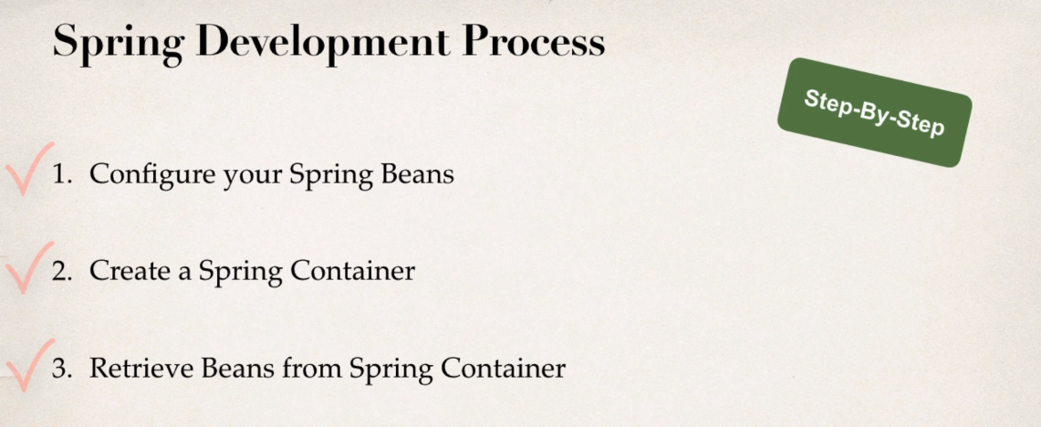

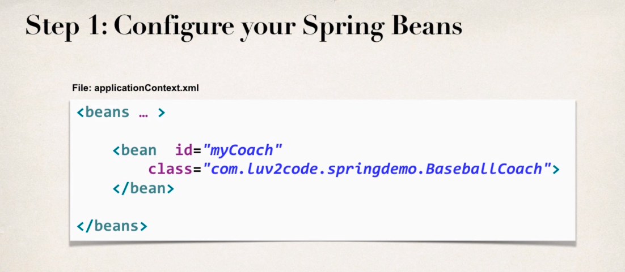

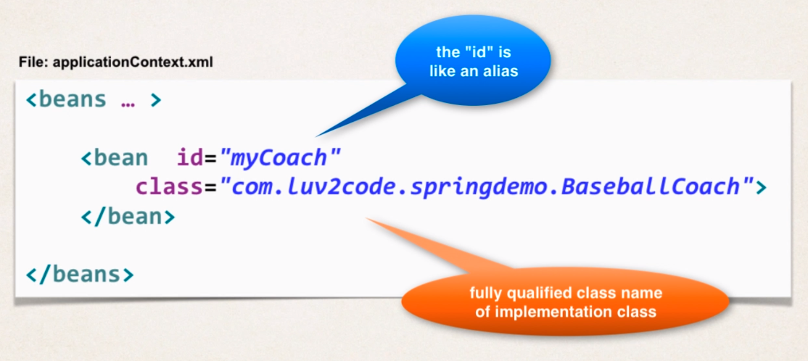

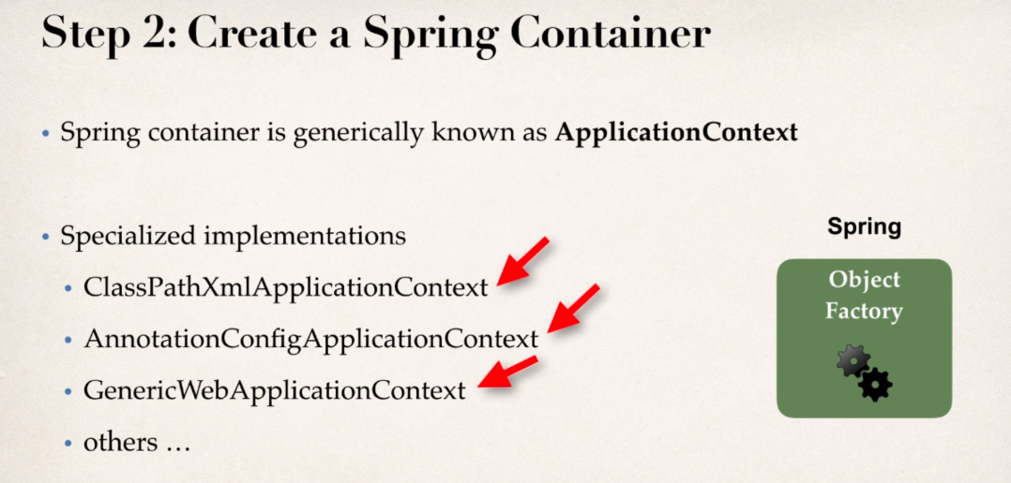

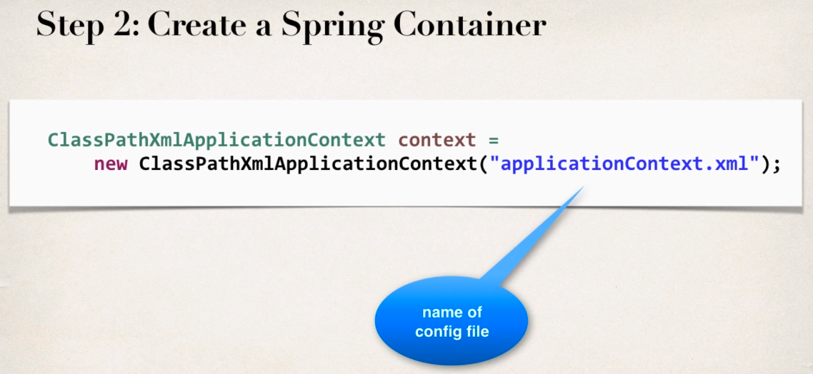

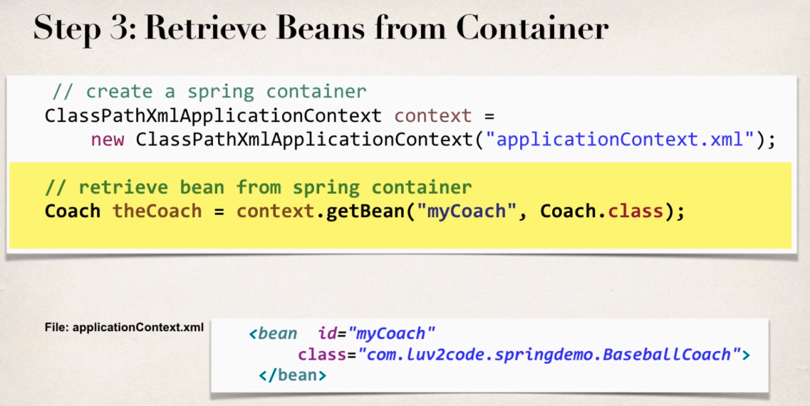

What is a Spring Bean ?

A “Spring Bean” is simply a Java Object.

When Java Objects are craeted by Spring Container , then Spring refers to them as “Spring Beans”.

Why do we specify the Coach interface in getBean()?

For example:

Coach theCoach = context.getBean("myCoach", Coach.class);

Answer

When we pass the interface to the method, behind the scenes Spring will cast the object for you.

context.getBean("myCoach", Coach.class)

**Spring Dependency Injection-XMl Conf**

Dependency Injection

Is basically , outsource the construction and injection of an object in to an external entity.

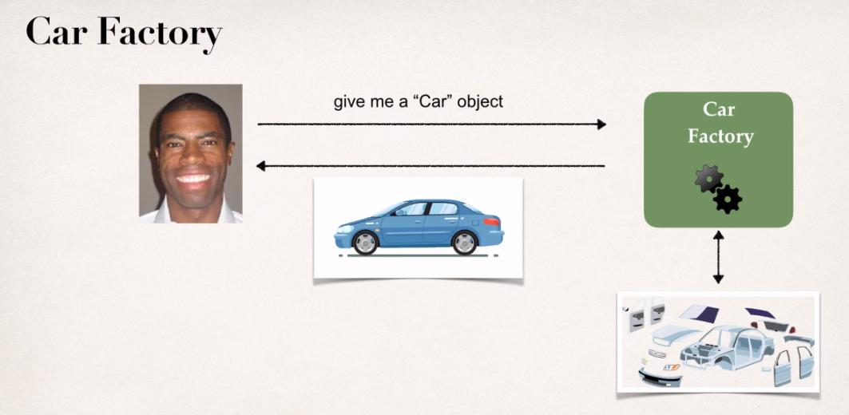

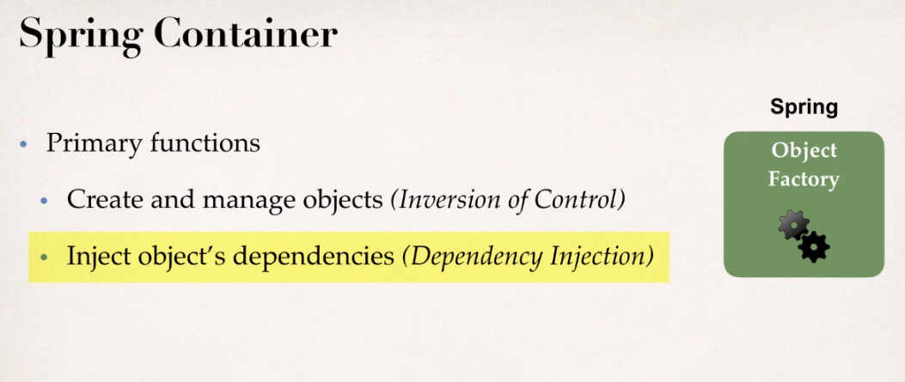

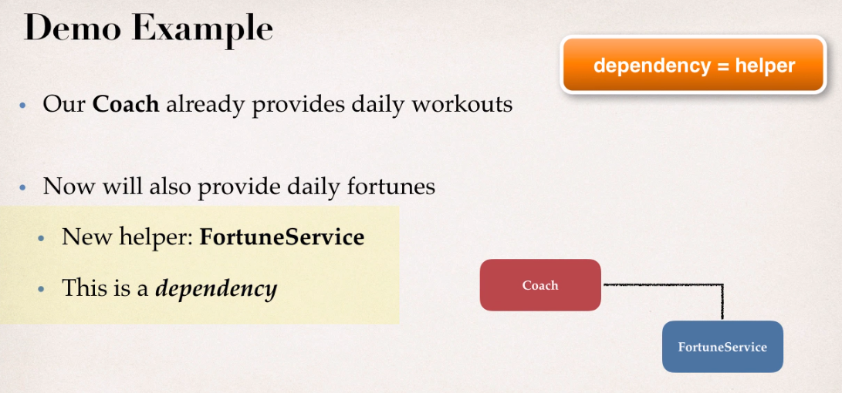

Basically there are different types of Dependency Injection.

1. Constructor Injection
2. Setter Injection
3. Autowiring using annotations.

**Constructor Injection**

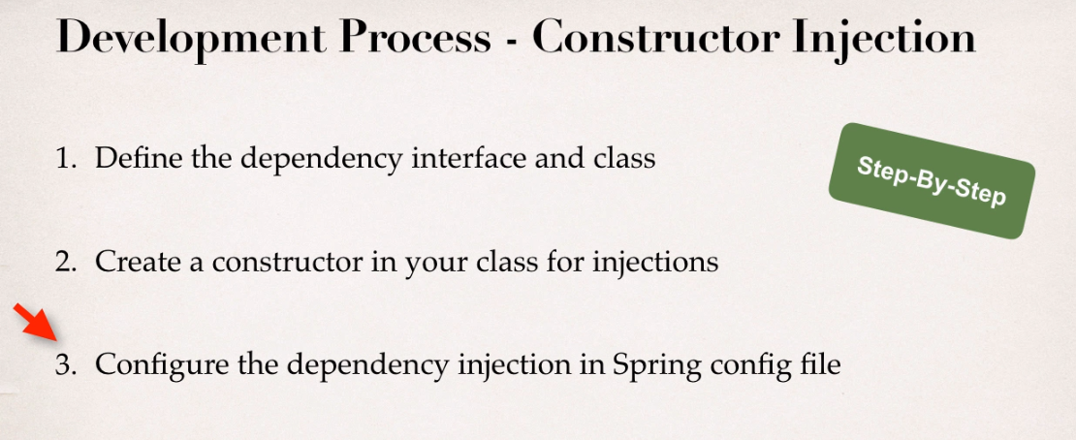

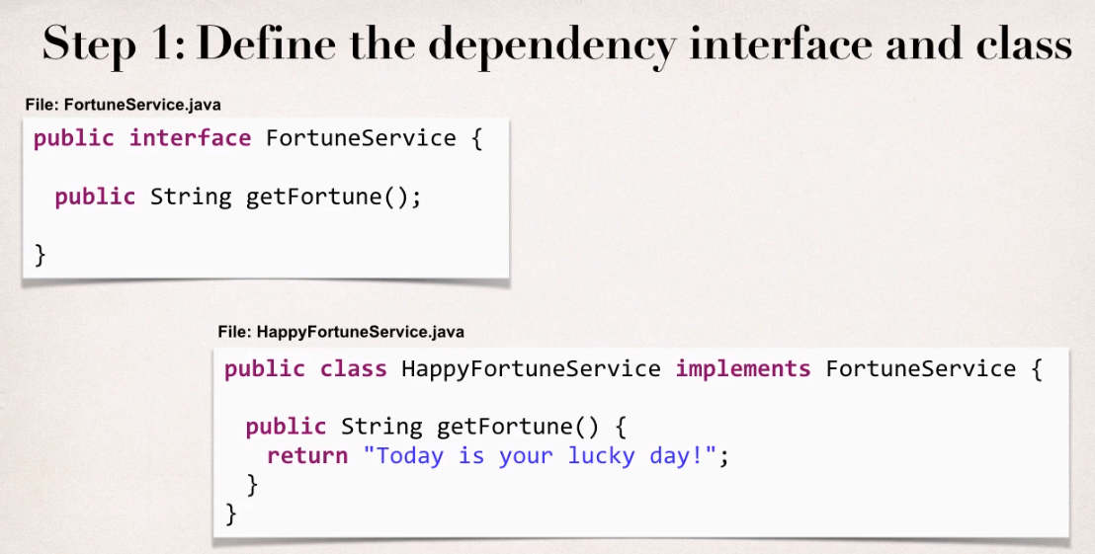

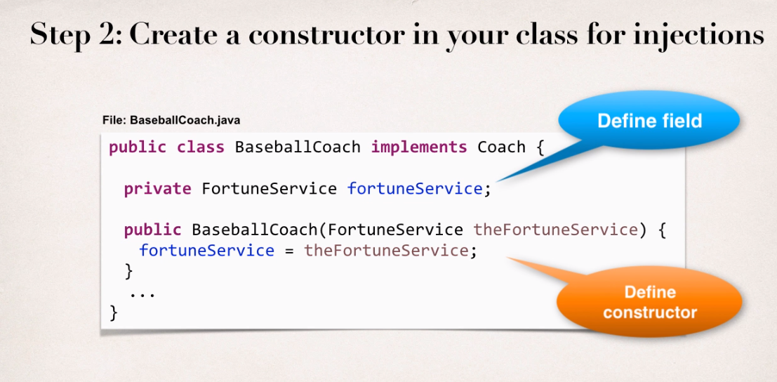

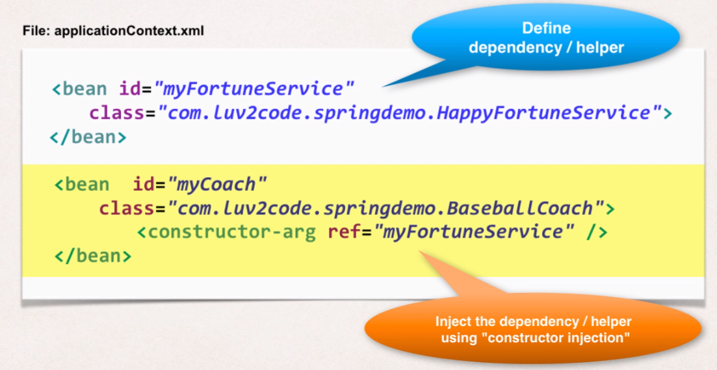

What happens behind the scenes , How this constructor injection works ?

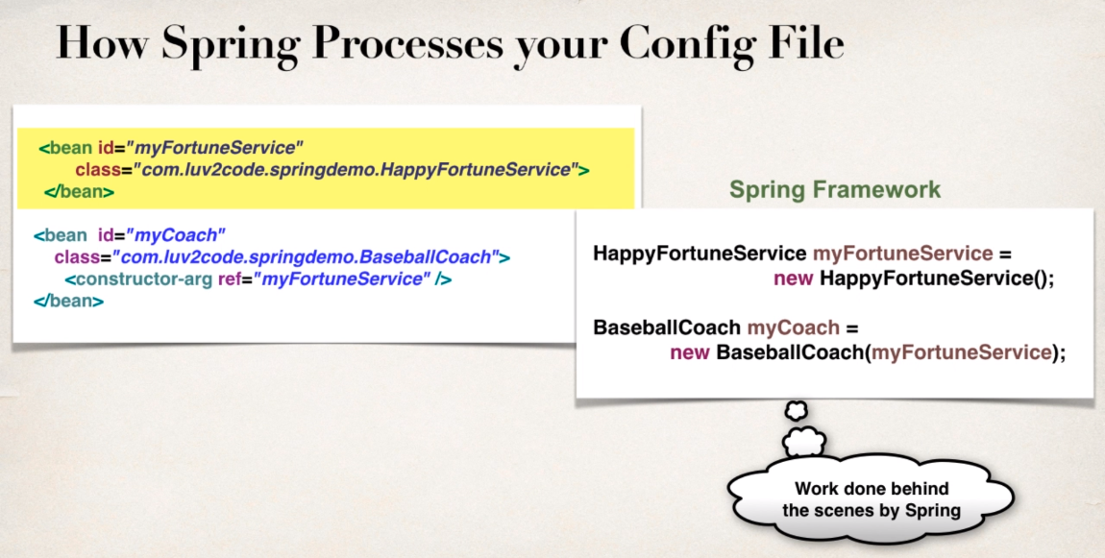

**Setter Injection**

Setter Injection

Inject dependencies by calling setter method on your class.

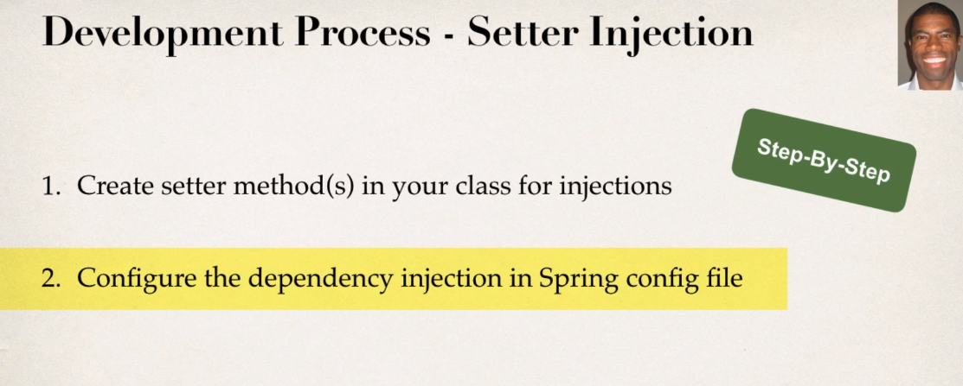

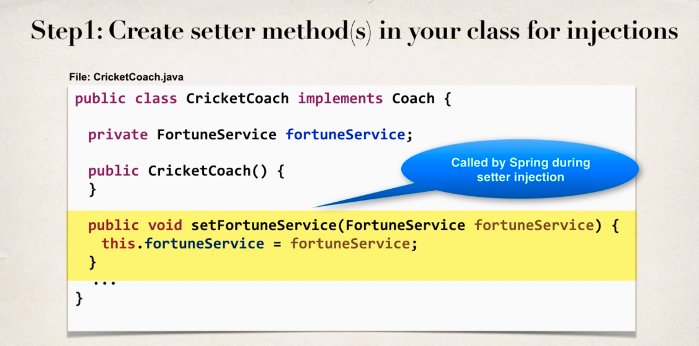

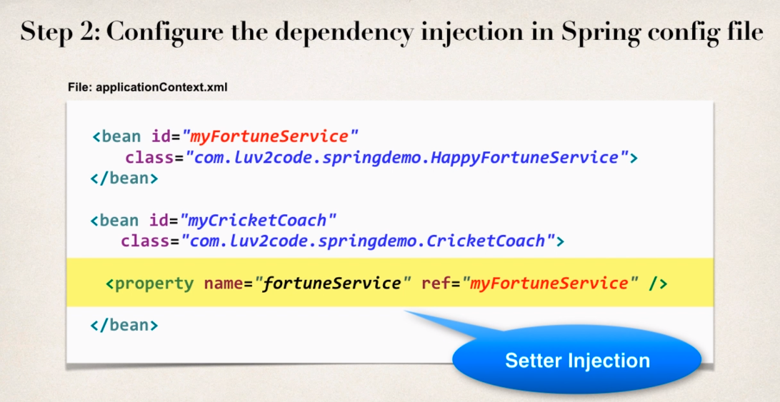

So behind the scenes , setter injection works like below ?

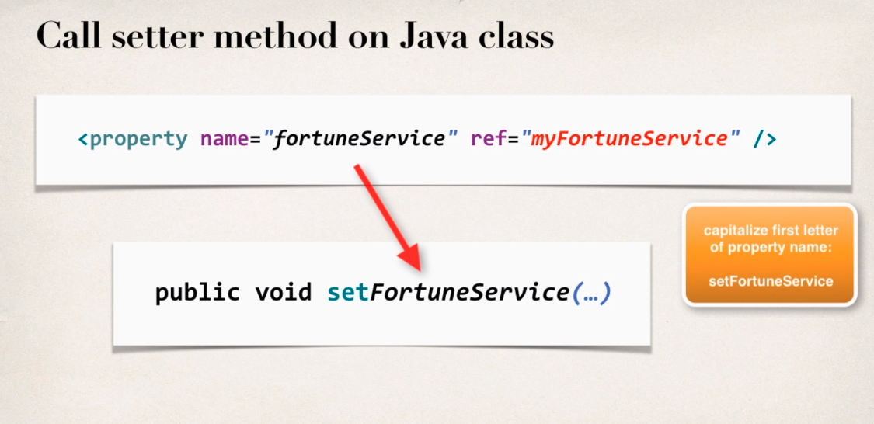

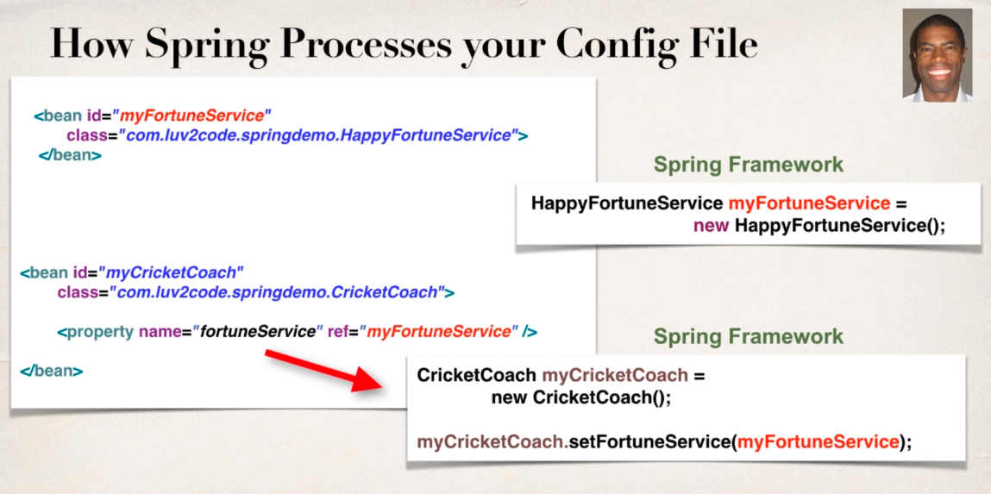

**Injecting Literal Values**

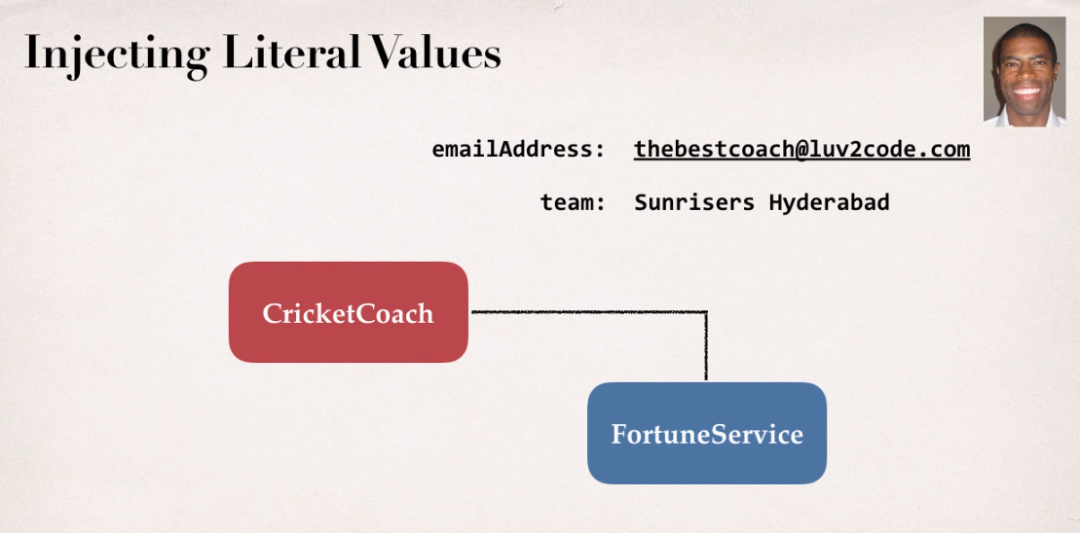

Here in the above image we want to insert the literal value.

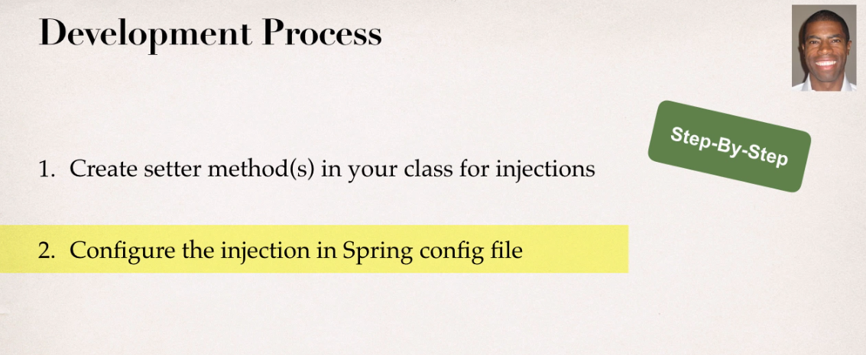

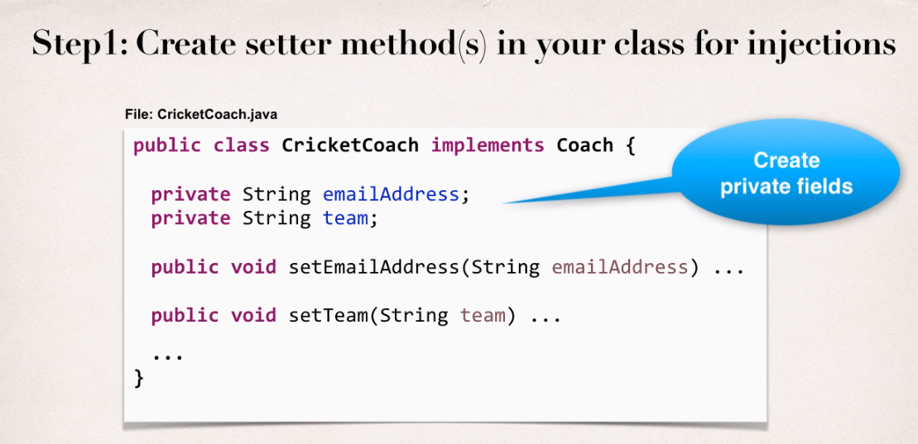

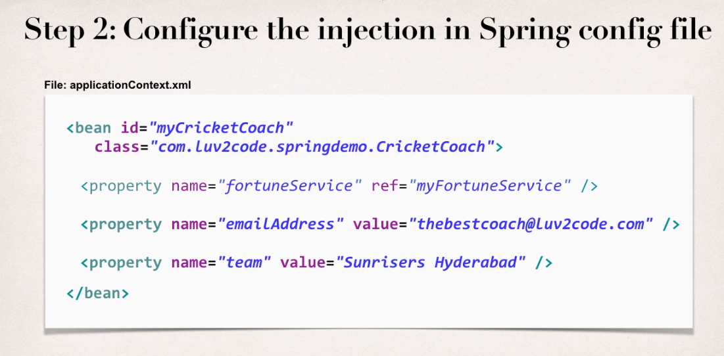

**Injecting Values from a Properties File**

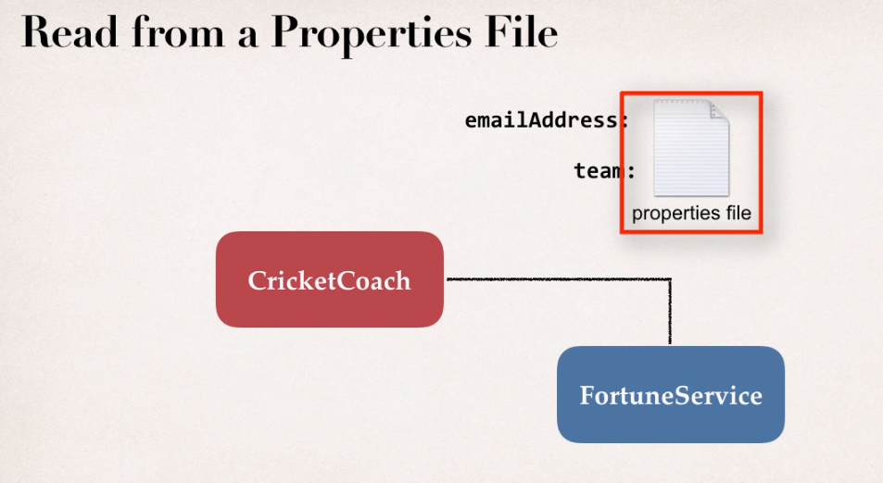

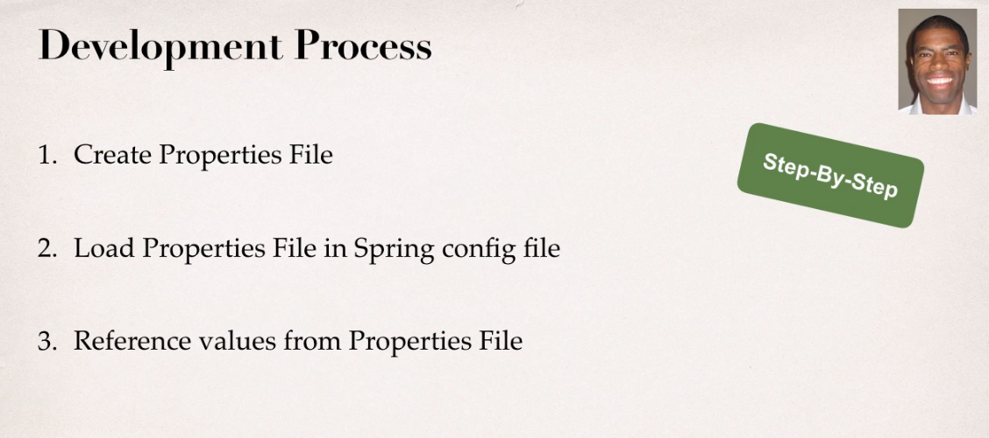

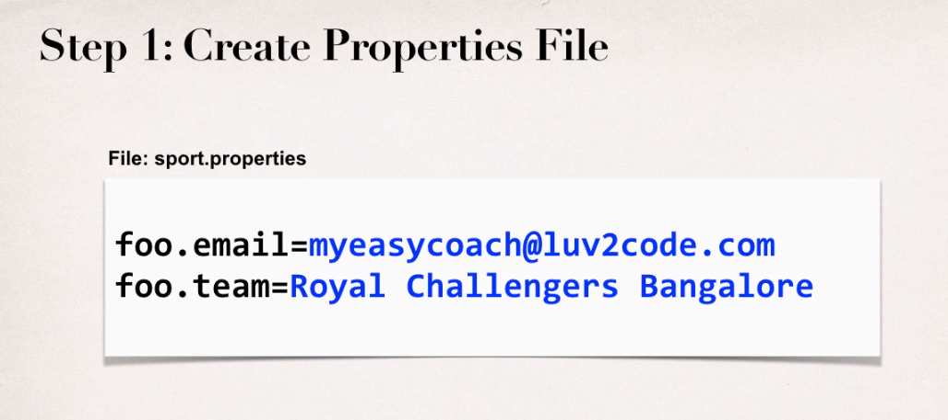

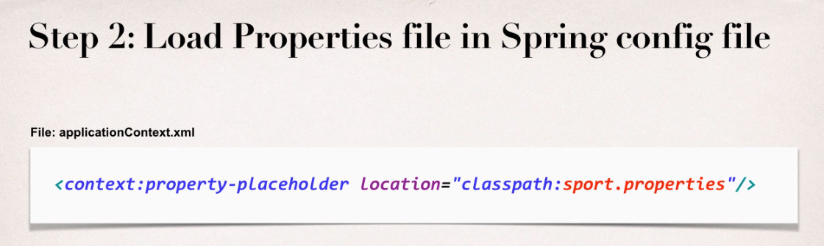

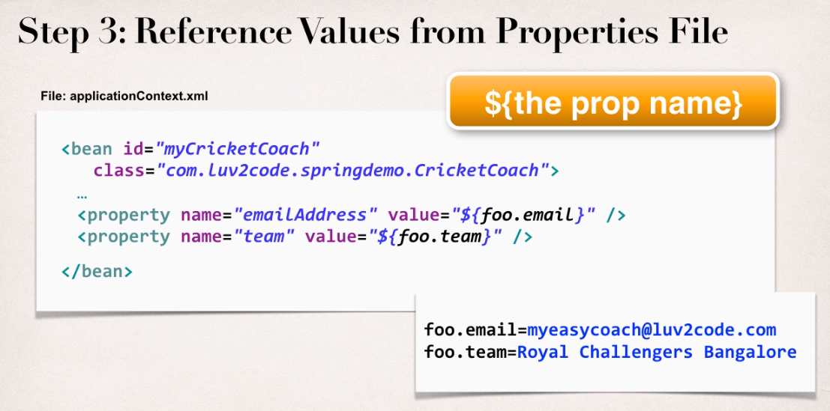

**Bean Scopes**

Scope refers to the lifecycle of the bean.

Specifically

How long does the bean live ?

How many instances are created ?

How is the bean shared ?

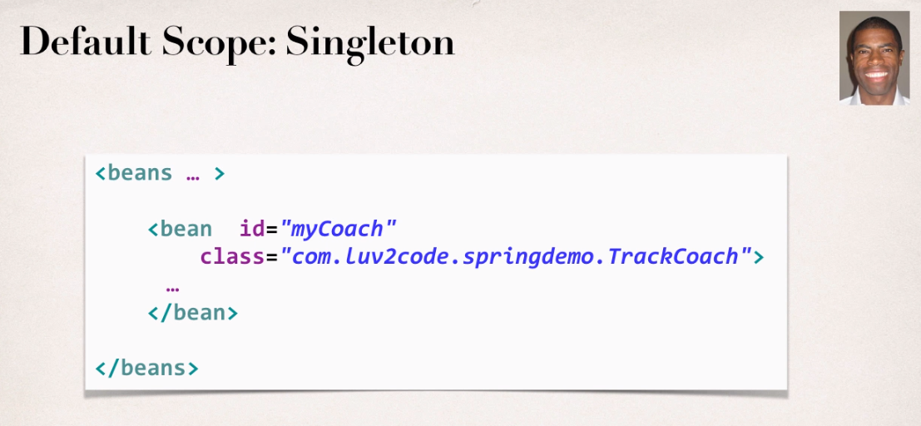

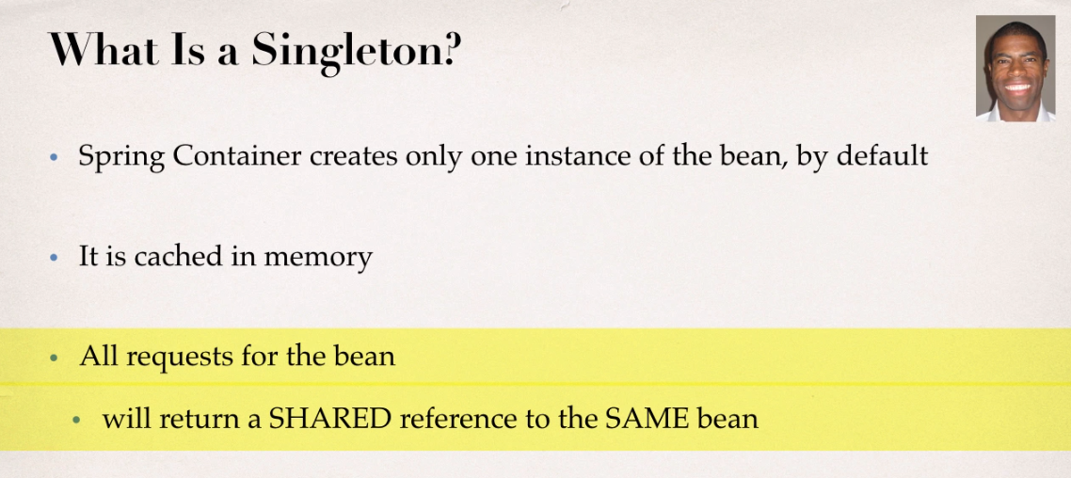

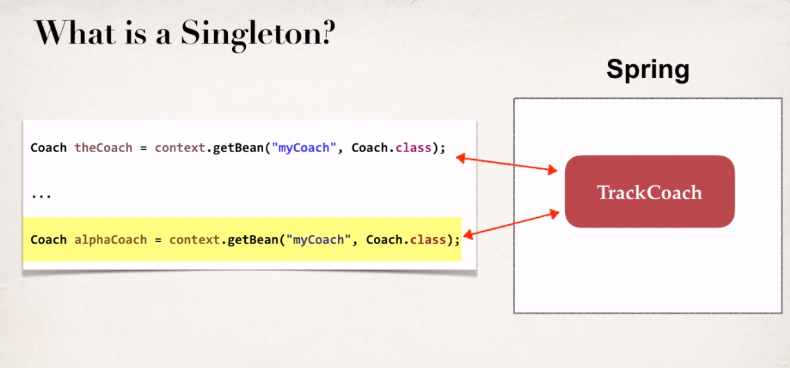

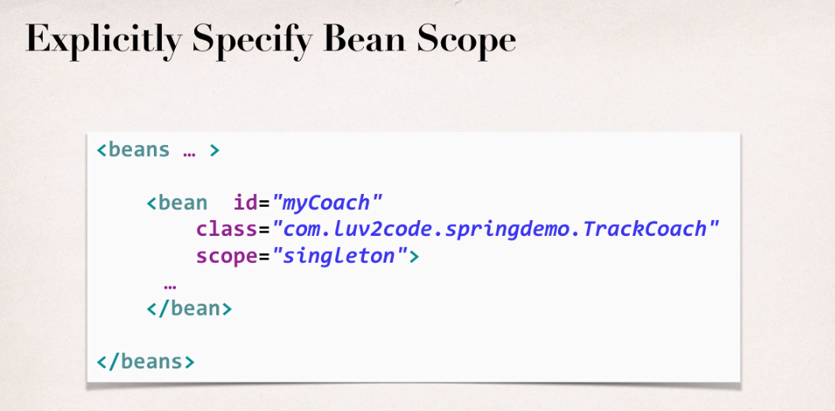

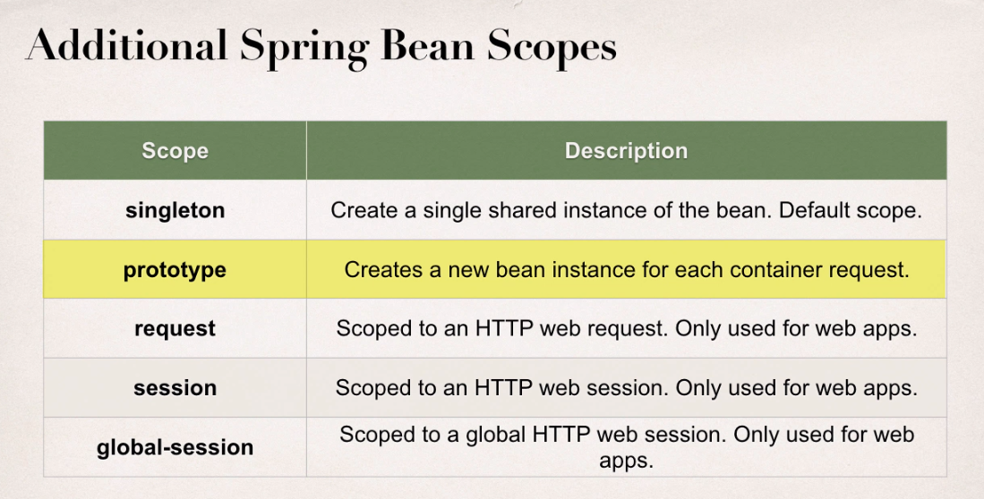

Request , sessiom and global-session are only used in web environments.

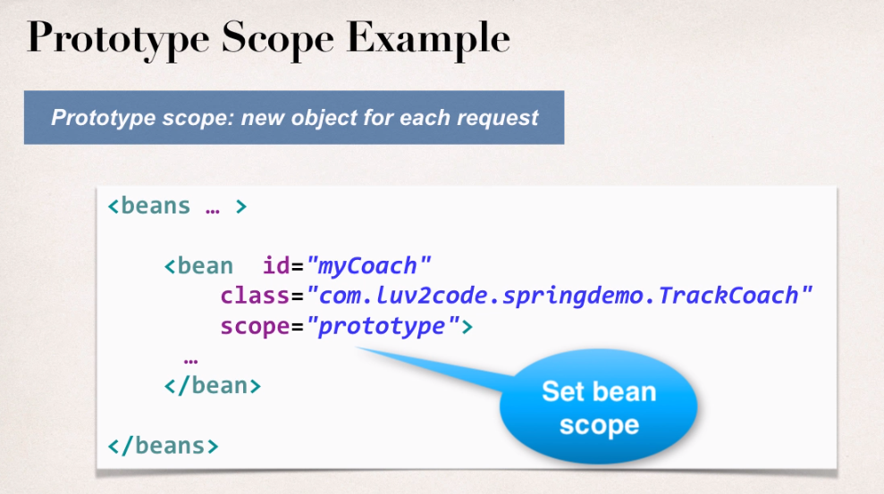

**Bean LifeCycle Method**

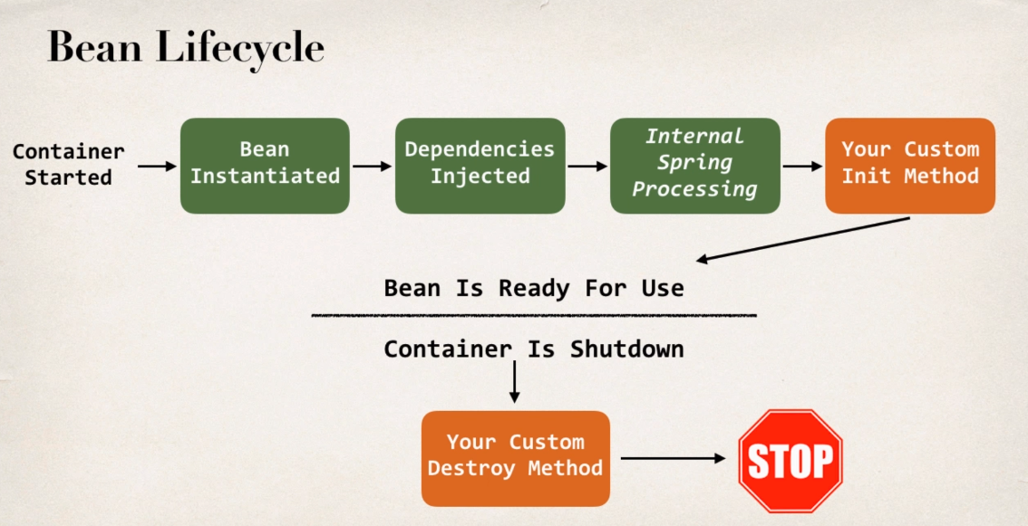

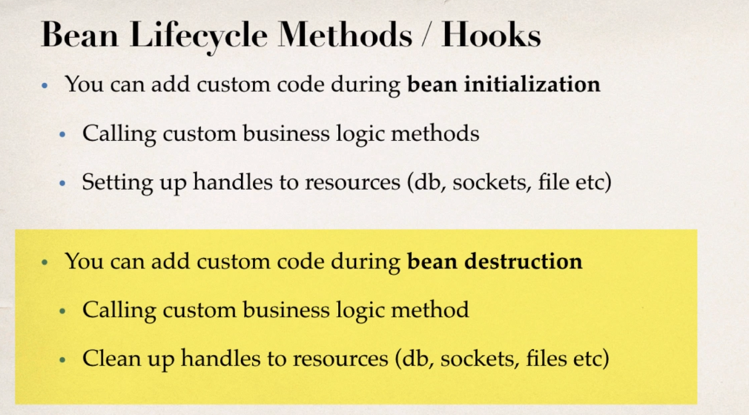

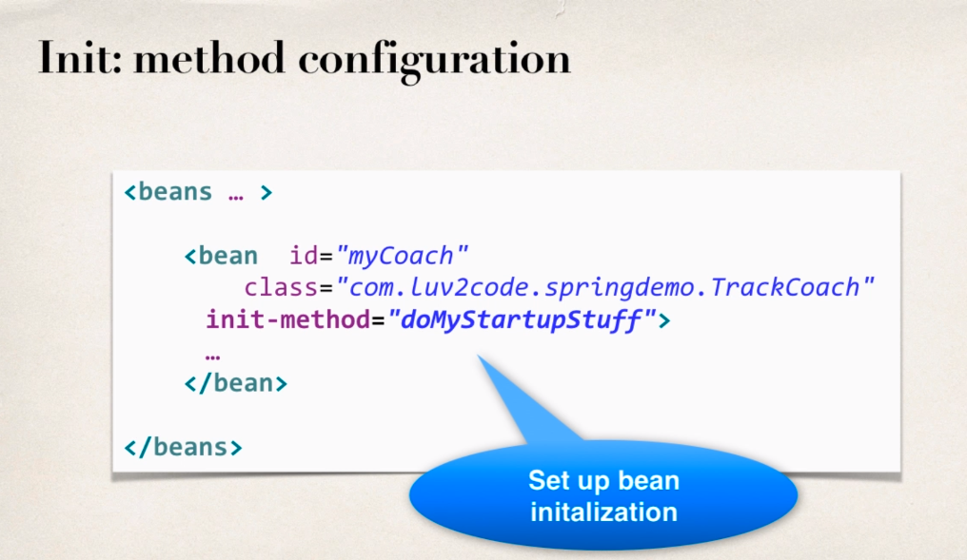

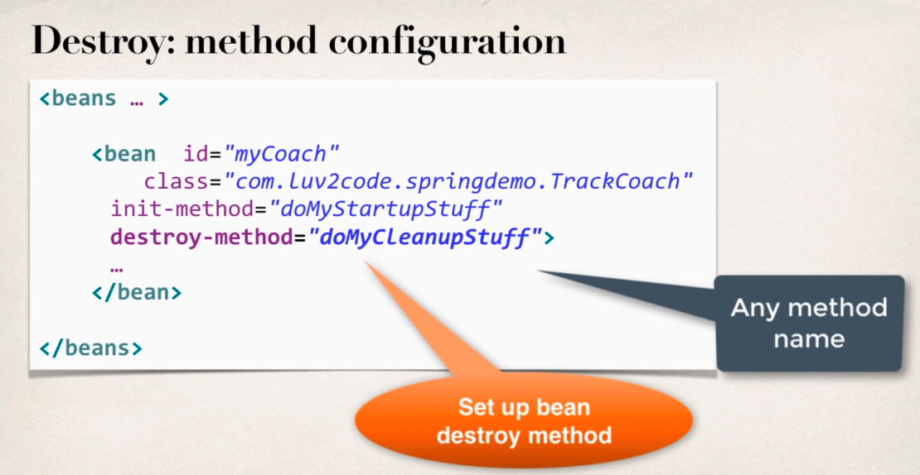

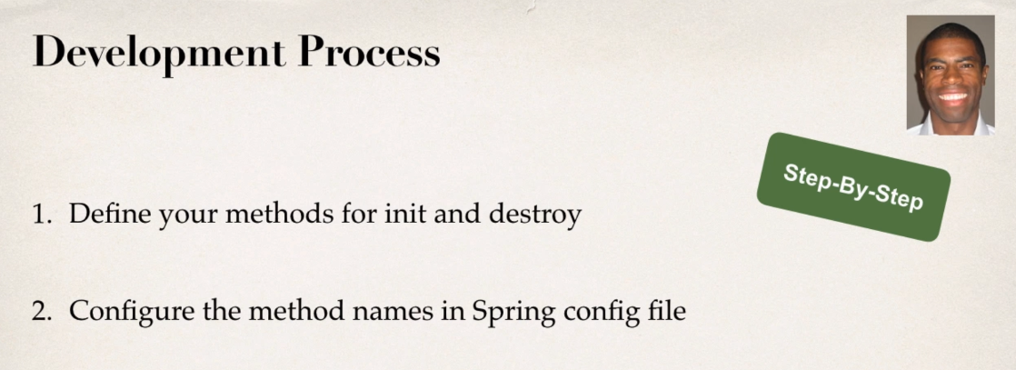

**Special Note about init and destroy Method Signatures**

When using XML configuration, I want to provide additional details regarding the method signatures of the init-method  and destroy-method .

**Access modifier**  
The method can have any access modifier (public, protected, private)

**Return type**  
The method can have any return type. However, "void' is most commonly used. If you give a return type just note that you will not be able to capture the return value. As a result, "void" is commonly used.

**Method name**  
The method can have any method name.

**Arguments**  
The method can not accept any arguments. The method should be no-arg.

**Most Important Point**

Special Note about Destroy Lifecycle and Prototype Scope

There is a subtle point you need to be aware of with "prototype" scoped beans.

**For "prototype" scoped beans, Spring does not call the destroy method.  Gasp!**

---

***In contrast to the other scopes, Spring does not manage the complete lifecycle of a prototype bean****: the container instantiates, configures, and otherwise assembles a prototype object, and hands it to the client, with no further record of that prototype instance.*

*Thus, although initialization lifecycle callback methods are called on all objects regardless of scope,****in the case of prototypes, configured destruction lifecycle callbacks are not called****. The client code must clean up prototype-scoped objects and release expensive resources that the prototype bean(s) are holding.*

**Spring Configuration with Java Annotattion-IOC**

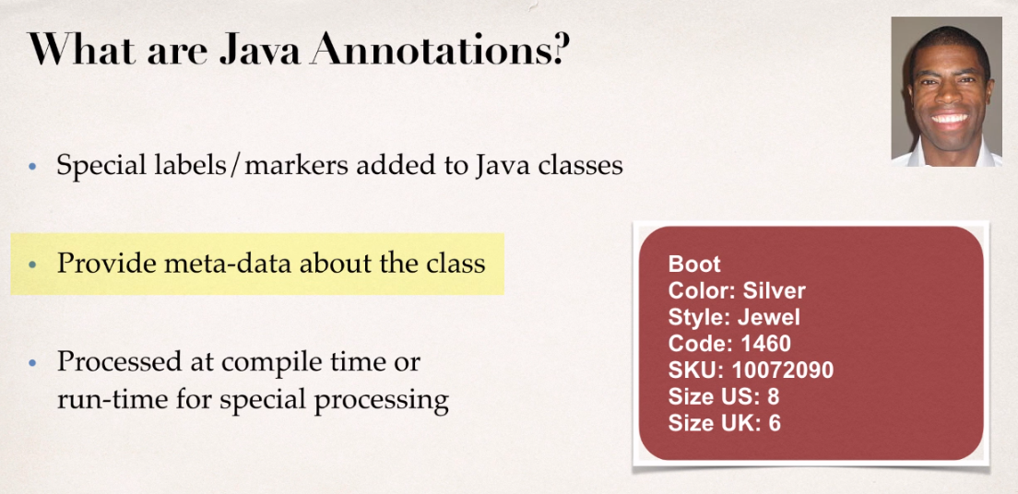

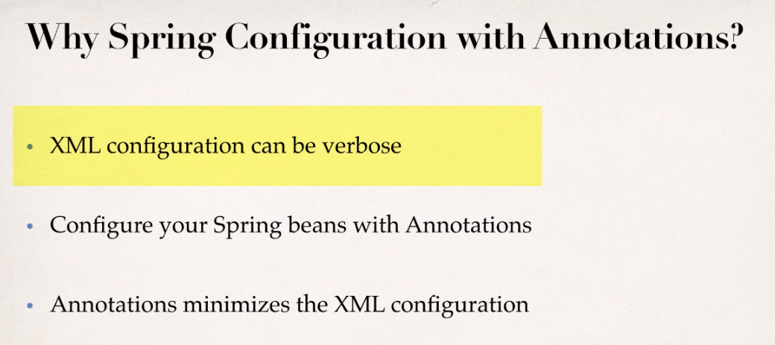

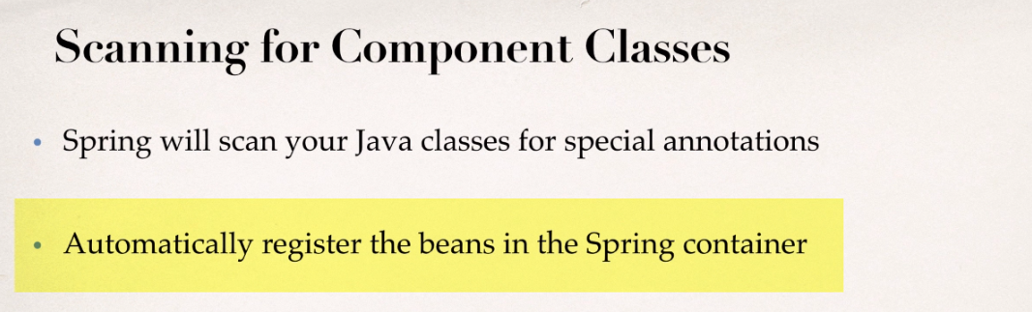

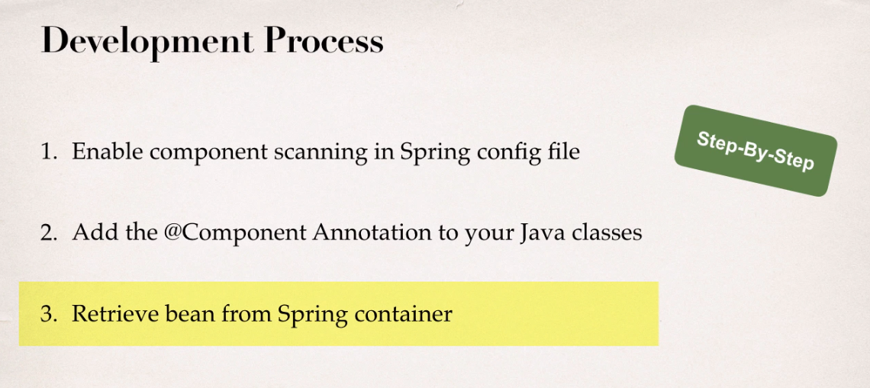

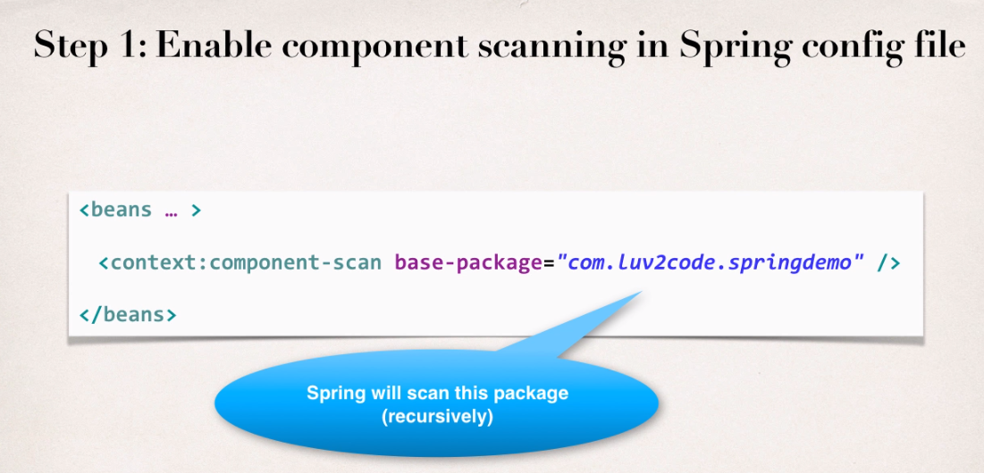

Spring actually go and scan all classes in the package and all the sub packages , identify the components having annotations on them and automatically registers them with the Spring container.

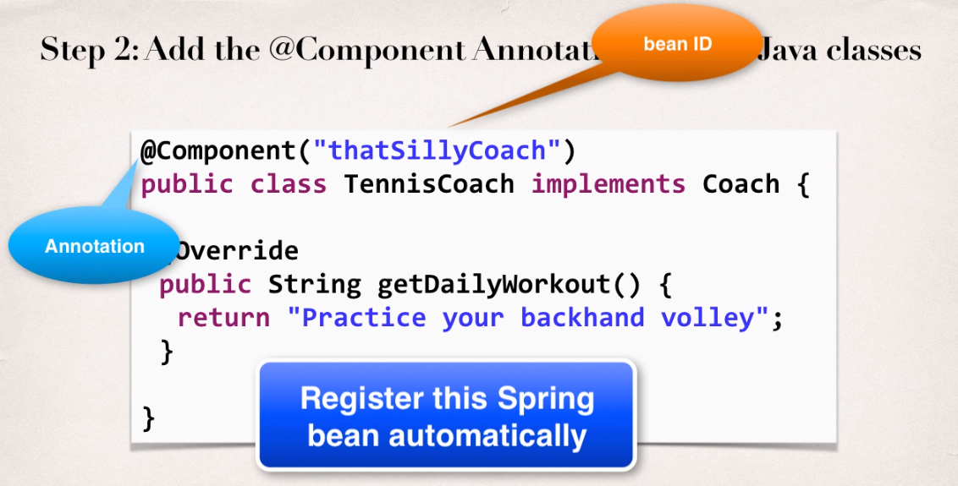

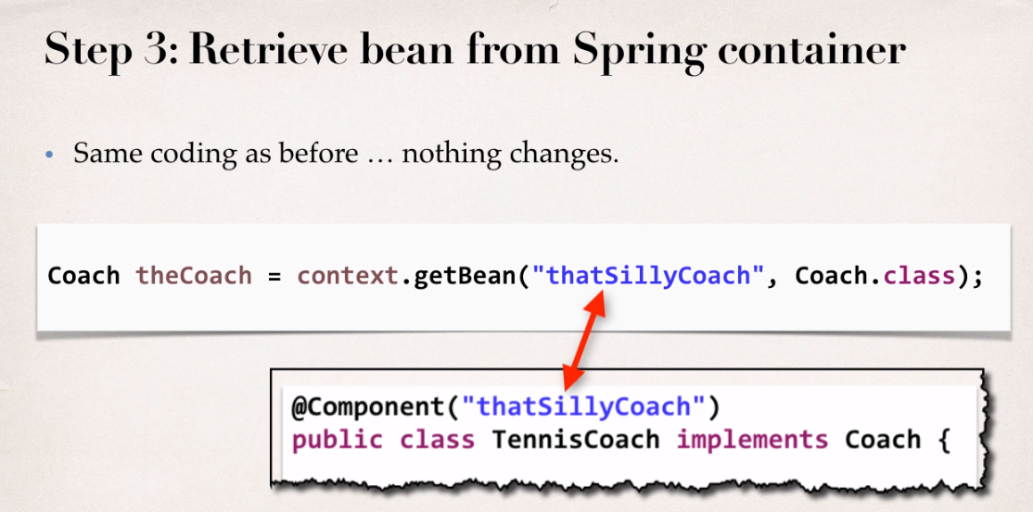

**Annotation: @Component**

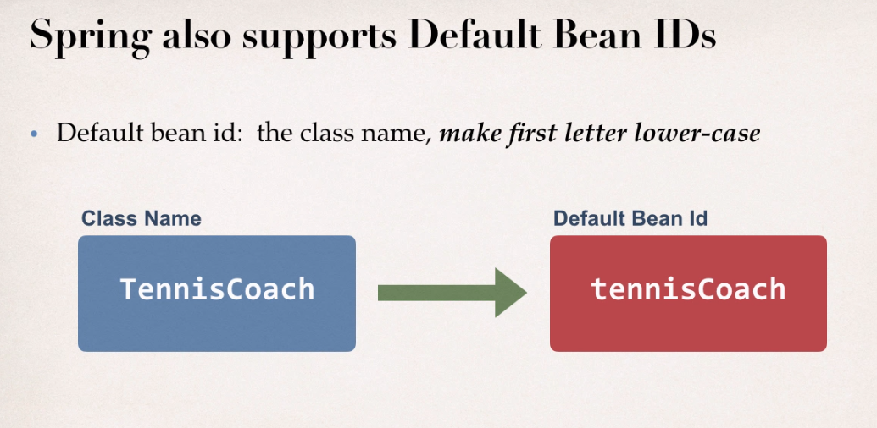

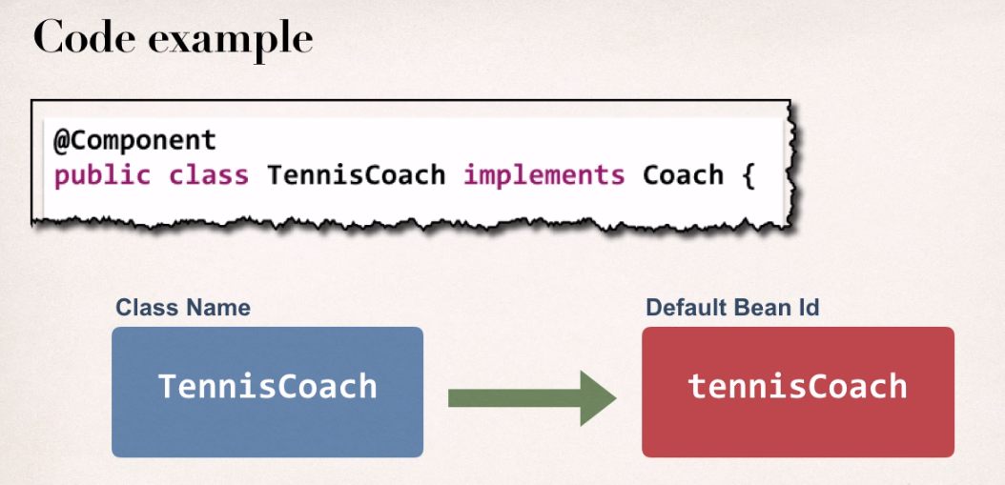

**Spring Dependency Injection with Annotations and Autowiring**

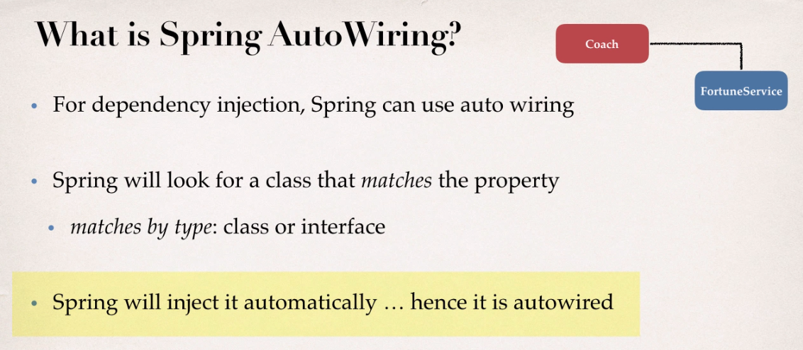

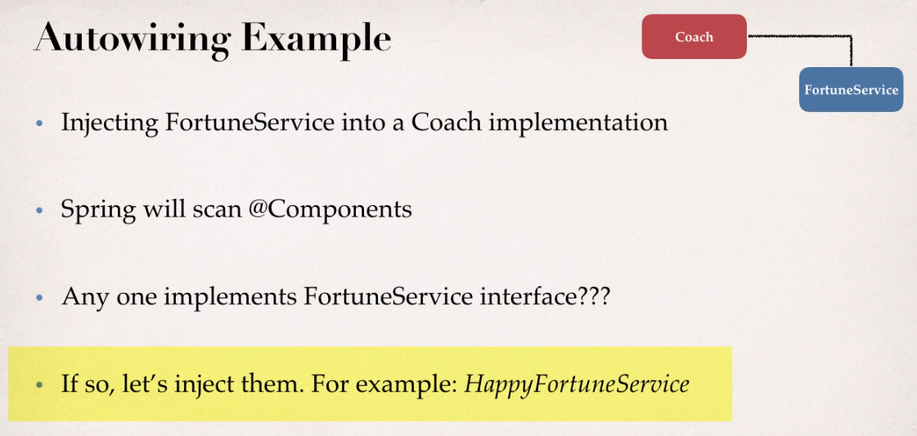

**Autowiring Injection types**

1. Constructor Injection
2. Setter Injection
3. Field Injection

**Constructor Injection**

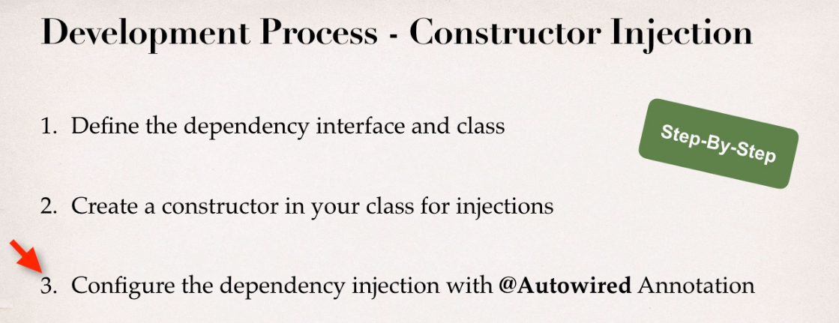

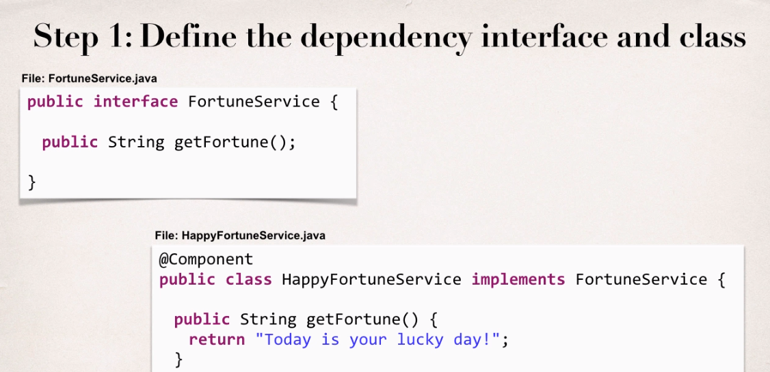

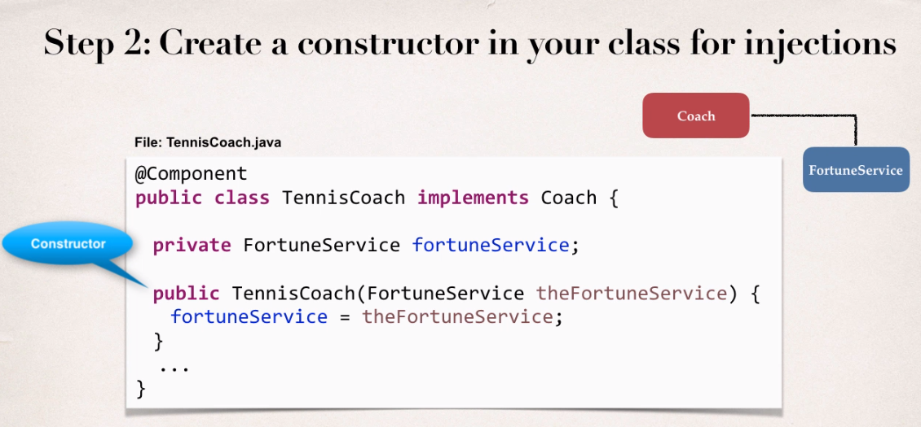

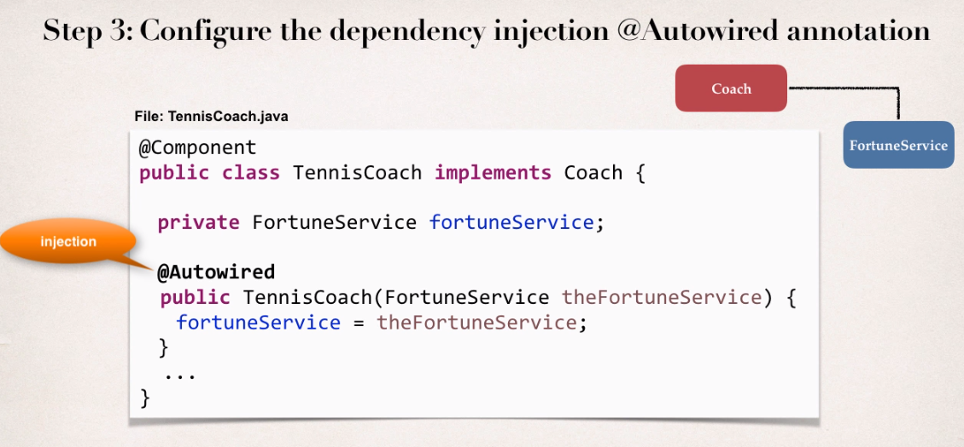

**Annotation : @Autowired**

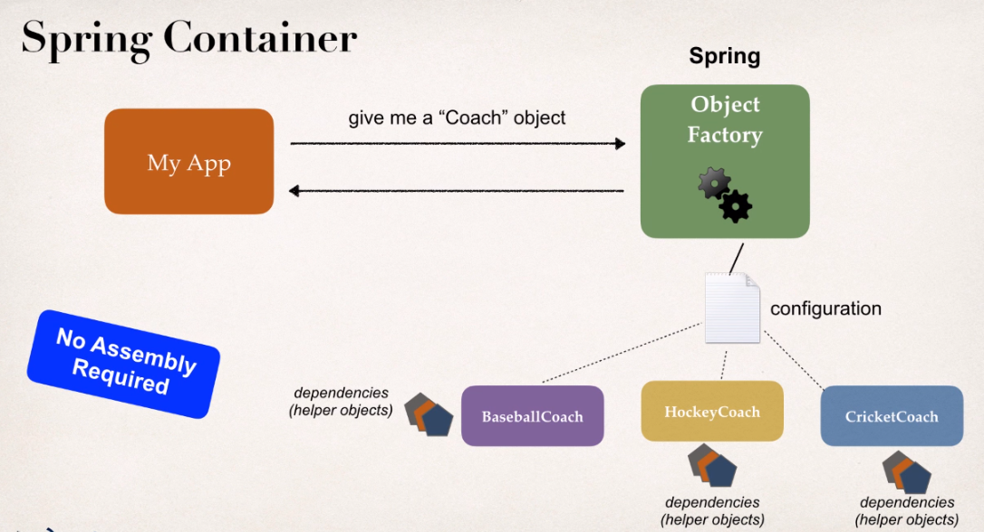

**Note:**

**AUTOWIRING**

**FAQ: What if there are multiple FortuneService implementations?**

When using autowiring, what if there are multiple FortuneService implementations? Like in the image below?  
  
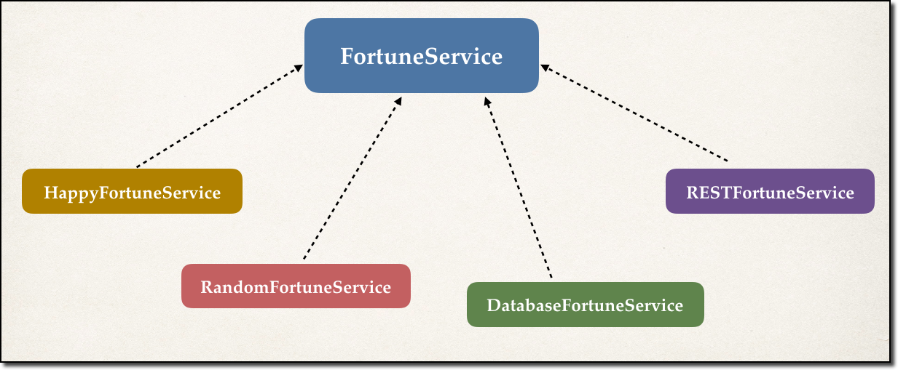

---

**ANSWER**

Spring has special support to handle this case. Use the **@Qualifier** annotation. We'll cover this later in the course with slides and code examples. But don't worry, we will address all scenarios :-)

**Important Note**

FAQ: Constructor Injection - Autowired Optional?

**Question**

I have finished the video "Constructor Injection - Writing Code part2".

I have commented the Autowired annotation. But still it worked. How did it work?

1. //@Autowired
2. public TennisCoach(FortuneService theFortuneService) {
3. System.out.println(" theFortuneService " + theFortuneService);
4. fortuneService = theFortuneService;
5. }

===

**Answer**

This is a new feature of Spring 4.3.

Here is the snippet from the Spring Docs.

**Section 1.9.2: Autowired**

*As of Spring Framework 4.3, an @Autowired annotation on such a constructor is no longer necessary if the target bean only defines one constructor to begin with. However, if several constructors are available, at least one must be annotated to teach the container which one to use.*

I personally prefer to use the @Autowired annotation because it makes the code more readable. But as mentioned, the @Autowired is not required for this scenario.

**Setter Injection**

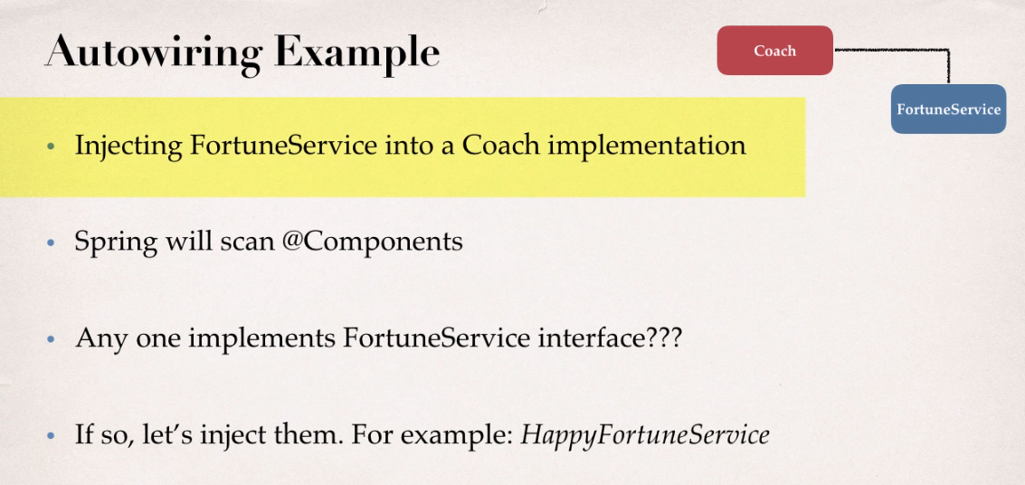

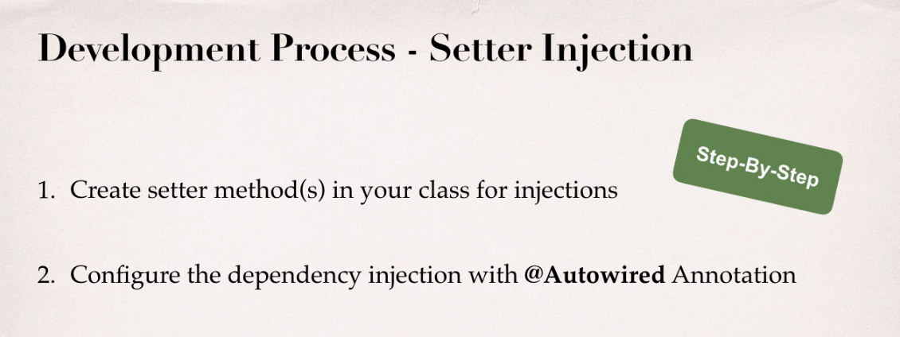

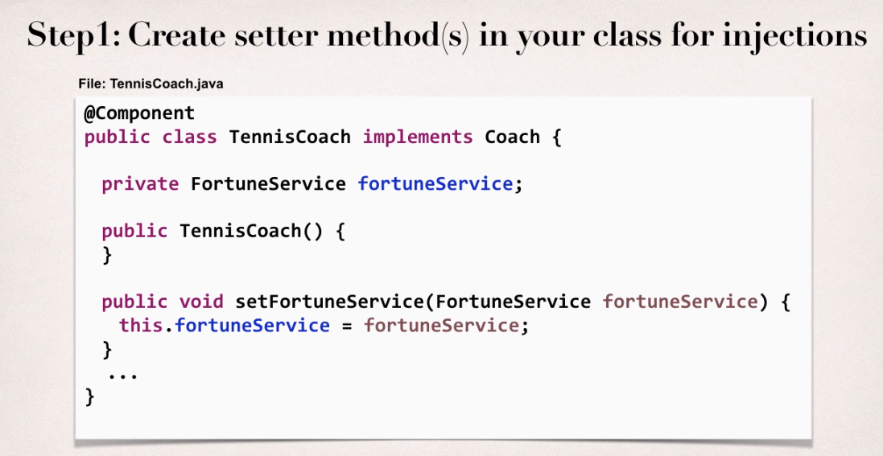

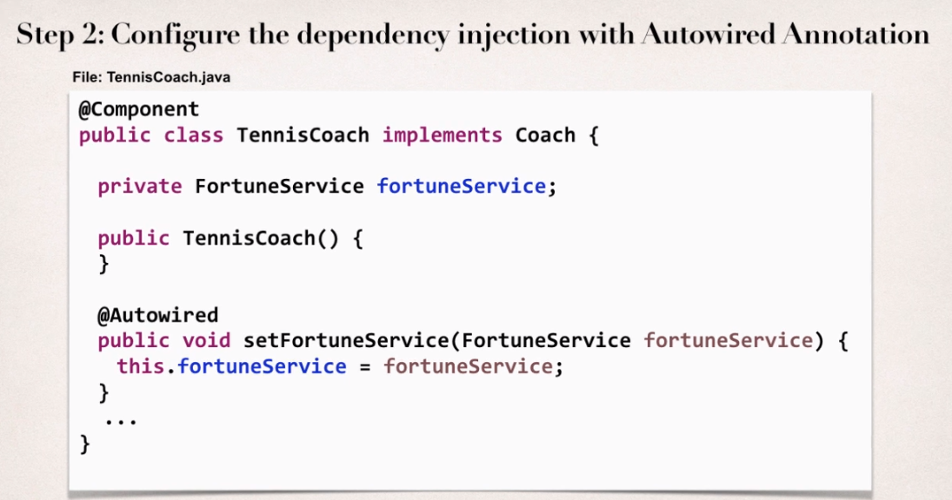

**Method Injection**

We can inject dependencies by calling Any method on your class.

Simply give : @Autowired

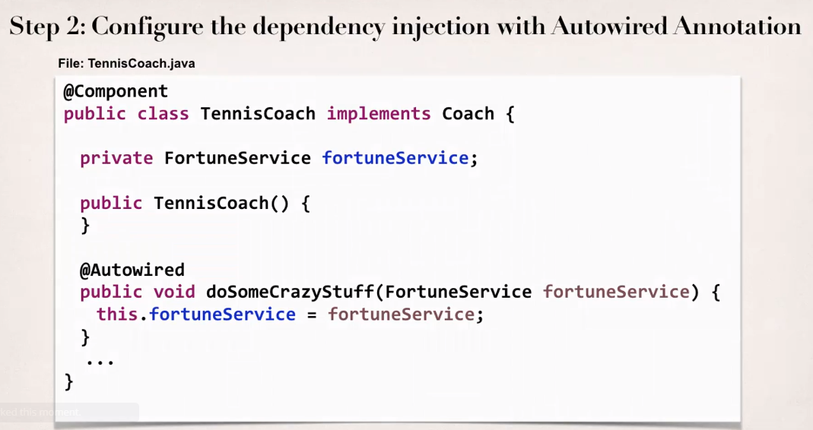

**Field Injection**

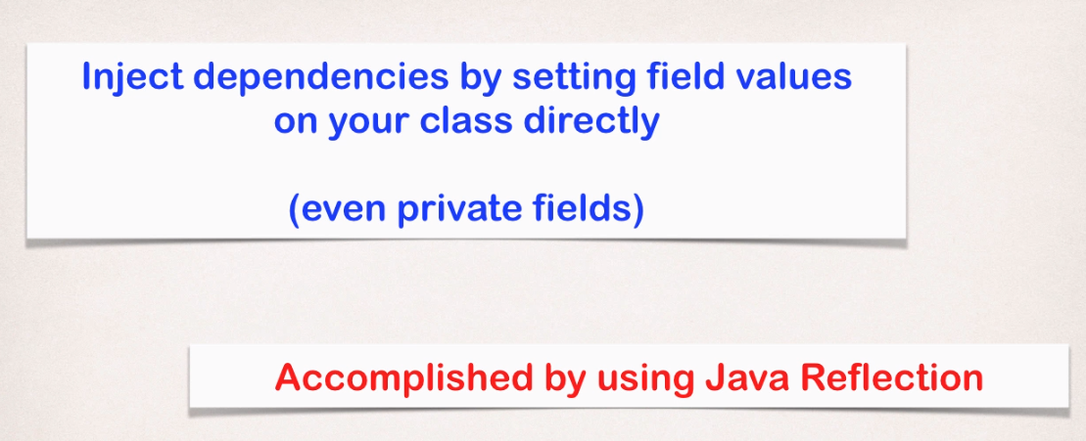

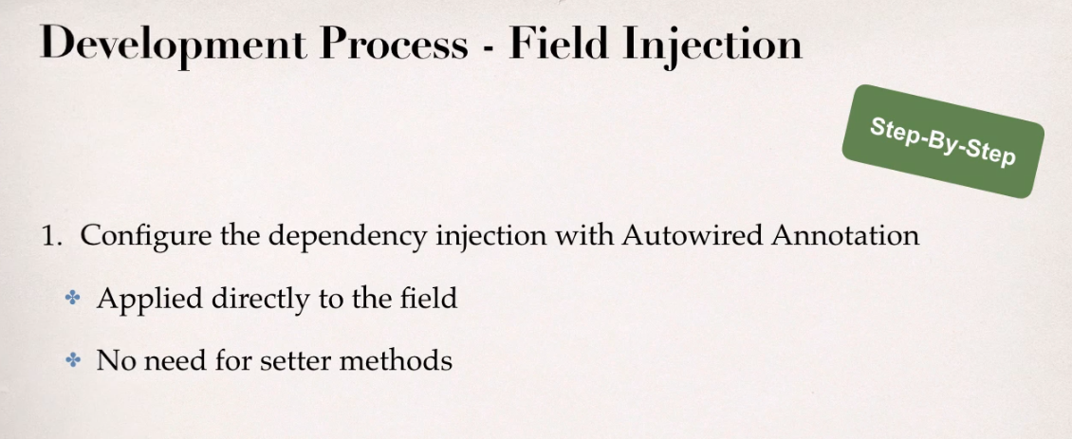

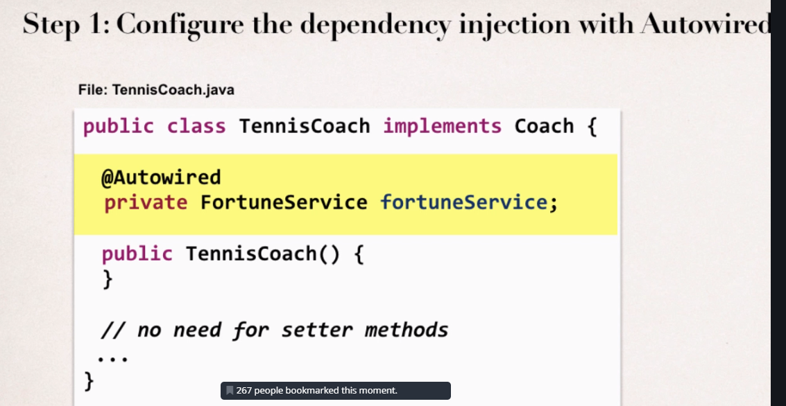

Which injection type should you use ?

All of them are equally good. Choose a style and stay consistent in your project.

**Annotation Autowiring and Qualifiers**

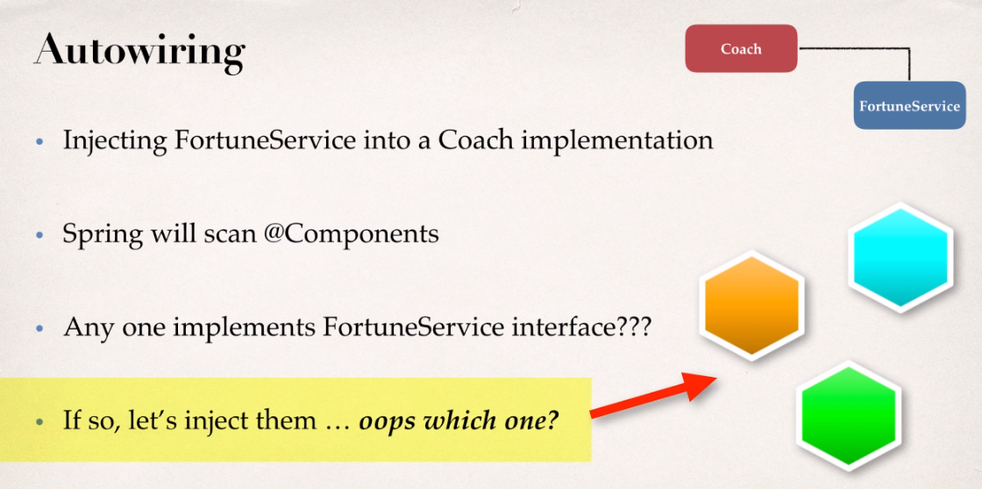

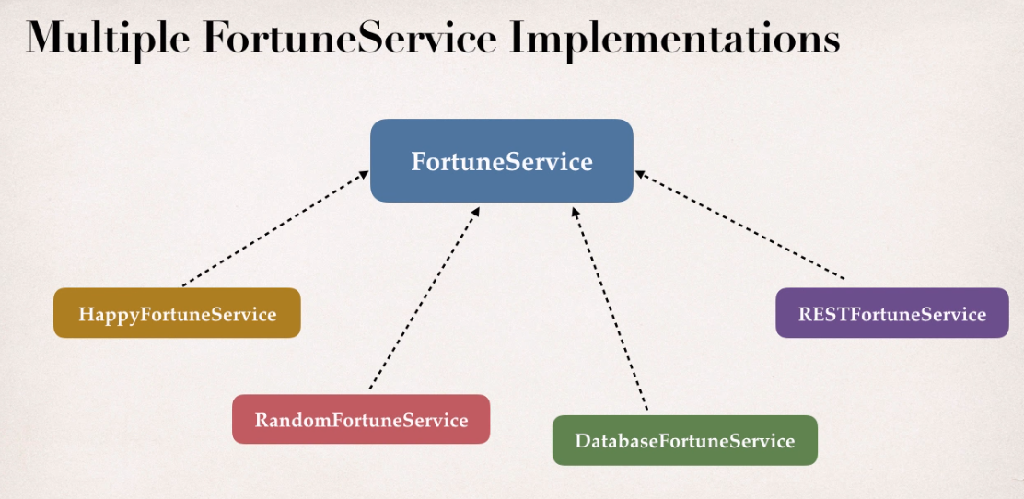

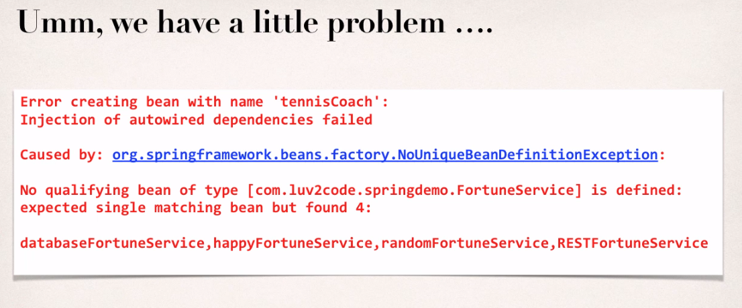

We need to tell Spring which specific Bean to use.

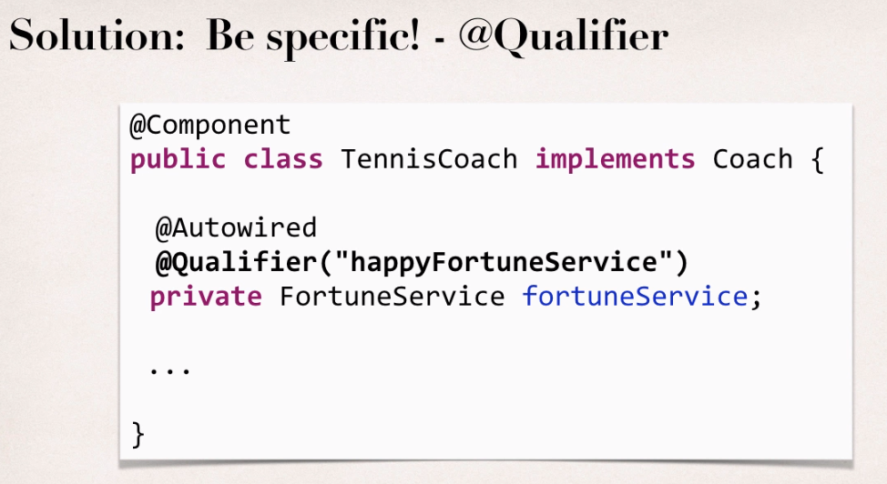

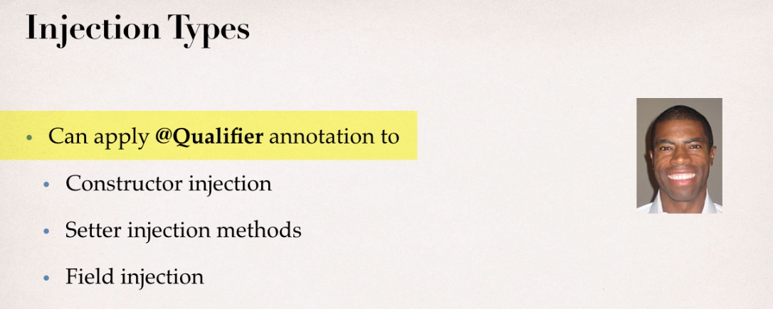

**Annotation: @Qualifier**

**Most Important Note**

Annotations - Default Bean Names - The Special Case

**Annotations - Default Bean Names ... and the Special Case**

In general, when using Annotations, for the default bean name, Spring uses the following rule.

*If the annotation's value doesn't indicate a bean name, an appropriate name will be built based on the short name of the class (with the first letter lower-cased).*

For example:

HappyFortuneService --> happyFortuneService

---

However, for the **special case of when BOTH the first and second characters of the class name are upper case**, then the **name is NOT converted**.

For the case of RESTFortuneService

RESTFortuneService --> RESTFortuneService

*No conversion* since the first two characters are upper case.

Behind the scenes, Spring uses the **Java Beans Introspector** to generate the default bean name. Here's a screenshot of the documentation for the key method.

Using @Qualifier with Constructors

**@Qualifier** is a nice feature, but it is tricky when used with Constructors.

The syntax is much different from other examples and not exactly intuitive.  Consider this the "deep end of the pool" when it comes to Spring configuration LOL :-)

 You have to place the @Qualifier annotation inside of the constructor arguments.

Here's an example from our classroom example. I updated it to make use of constructor injection, with @Autowired and @Qualifier. Make note of the code in bold below:

---  
package com.luv2code.springdemo;

import org.springframework.beans.factory.annotation.Autowired;

import org.springframework.beans.factory.annotation.Qualifier;  
import org.springframework.stereotype.Component;

@Component  
public class TennisCoach implements Coach {

    private FortuneService fortuneService;

    // define a default constructor  
    public TennisCoach() {  
        System.out.println(">> TennisCoach: inside default constructor");  
    }  
      
**@Autowired  
    public TennisCoach(@Qualifier("randomFortuneService") FortuneService theFortuneService) {**

**System.out.println(">> TennisCoach: inside constructor using @autowired and @qualifier");  
          
        fortuneService = theFortuneService;  
    }**         
      
    /*  
    @Autowired  
    public void doSomeCrazyStuff(FortuneService theFortuneService) {  
        System.out.println(">> TennisCoach: inside doSomeCrazyStuff() method");  
        fortuneService = theFortuneService;  
    }  
    */  
      
    /*  
    @Autowired  
    public TennisCoach(FortuneService theFortuneService) {  
        fortuneService = theFortuneService;  
    }  
    */  
      
    @Override  
    public String getDailyWorkout() {  
        return "Practice your backhand volley";  
    }

    @Override  
    public String getDailyFortune() {  
        return fortuneService.getFortune();  
    }

}

FAQ: How to inject properties file using Java annotations

**FAQ: How to inject properties file using Java annotations**

**Answer:**

This solution will show you how inject values from a properties file using annotatons. The values will no longer be hard coded in the Java code.

**1. Create a properties file to hold your properties. It will be a name value pair.**

New text file:  src/sport.properties

1. foo.email=myeasycoach@luv2code.com
2. foo.team=Silly Java Coders

Note the location of the properties file is very important. It must be stored in src/sport.properties

**2. Load the properties file in the XML config file.**

File: applicationContext.xml

Add the following lines:

    <context:property-placeholder location="classpath:sport.properties"/>

This should appear just after the <context:component-scan .../> line

**3. Inject the properties values into your Swim Coach: SwimCoach.java**

1. @Value("${foo.email}")
2. private String email;
4. @Value("${foo.team}")
5. private String team;

**Bean Scopes and Lifecycle Methods with Annotations**

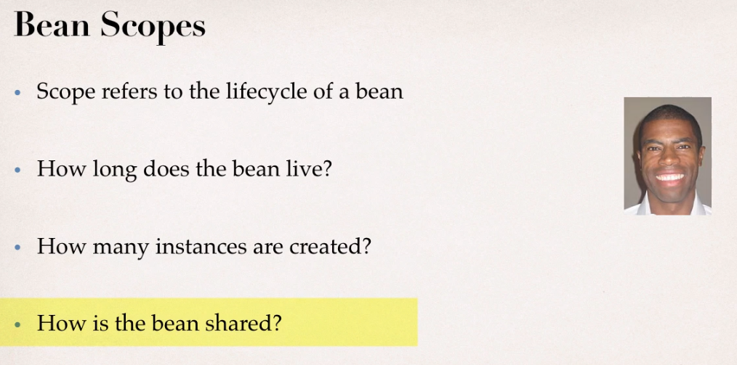

Default scope is singleton.

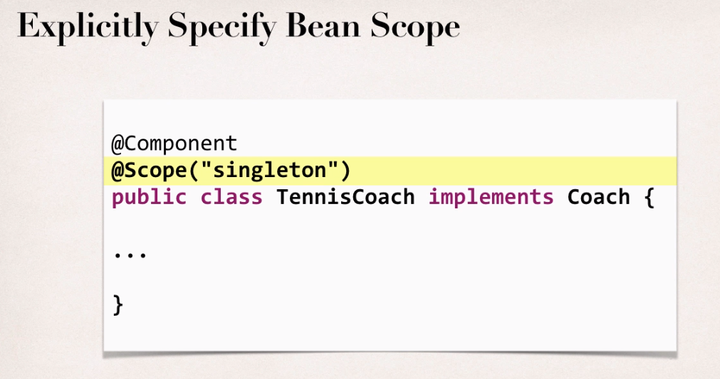

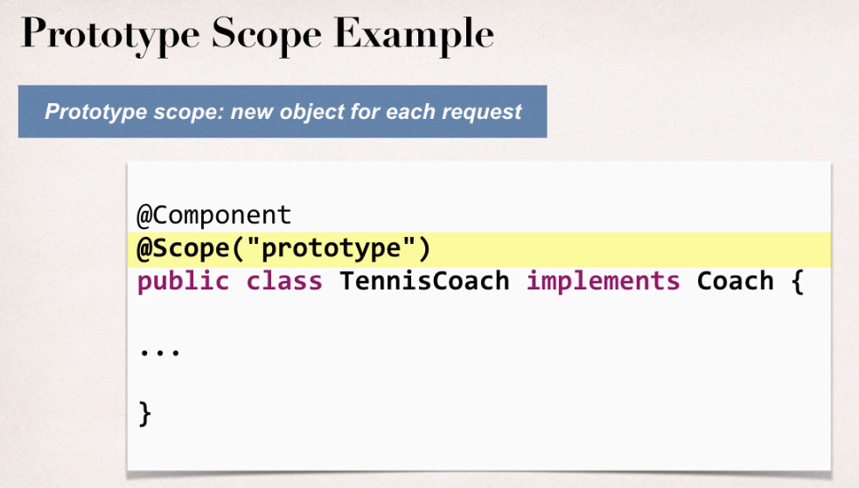

**Annotation: @Scope(“prototype”)**

**Bean Lifecycle Method Annotation**

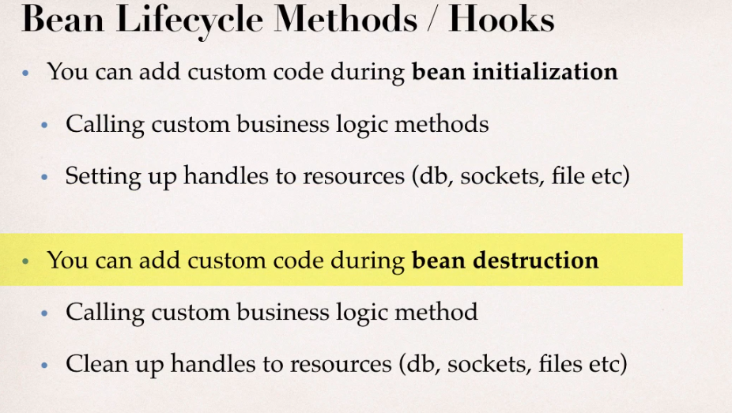

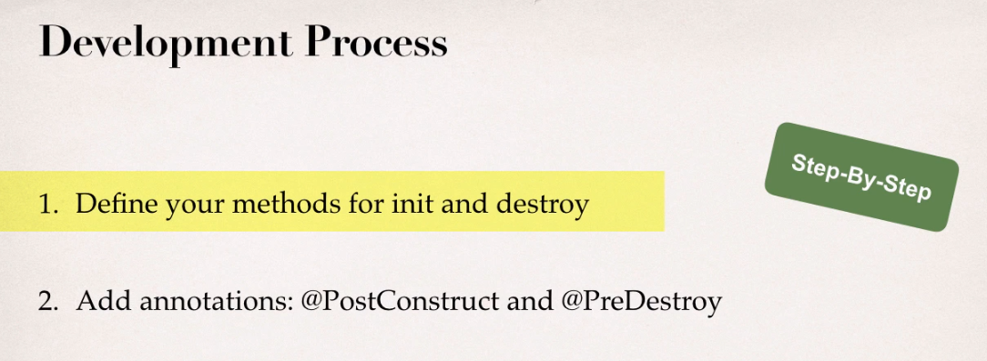

**Annotations : @PostConstruct and @PreDestroy**

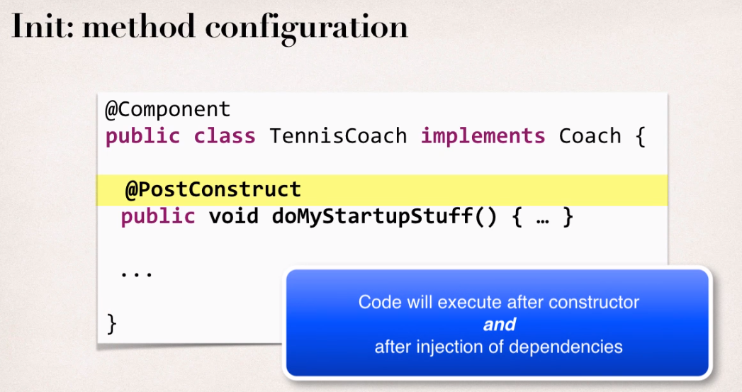

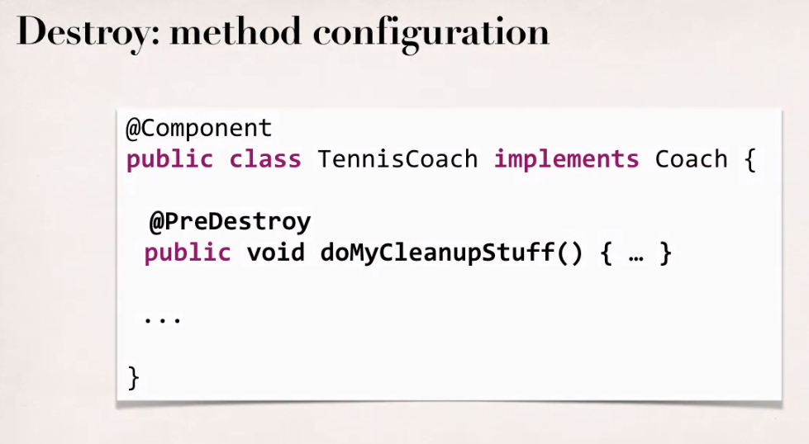

**Note**

Special Note about @PostConstruct and @PreDestroy Method Signatures

***Special Note about @PostConstruct and @PreDestroy Method Signatures***

I want to provide additional details regarding the method signatures of @PostContruct and @PreDestroy methods.

**Access modifier**

The method can have any access modifier (public, protected, private)

**Return type**The method can have any return type. However, "void' is most commonly used. If you give a return type just note that you will not be able to capture the return value. As a result, "void" is commonly used.

**Method name**The method can have any method name.

**Arguments**The method can not accept any arguments. The method should be no-arg.

**Note for Java 9 onwards**

HEADS UP - FOR JAVA 9 USERS - @PostConstruct and @PreDestroy

**HEADS UP - FOR JAVA 9, 10 and 11 USERS - @PostConstruct and @PreDestroy**

If you are using Java 9, 10 or 11, then you will encounter an error when using @PostConstruct and @PreDestroy in your code.

These are the steps to resolve it. Come back to the lecture if you hit the error.

***Error***

Eclipse is unable to import @PostConstruct or @PreDestroy

This happens because of Java 9 and higher.

When using Java 9 and higher, javax.annotation has been removed from its default classpath. That's why we Eclipse can't find it.

---

***Solution***

1. Download the *javax.annotation-api-1.2.jar* from

<http://central.maven.org/maven2/javax/annotation/javax.annotation-api/1.2/javax.annotation-api-1.2.jar>

2. Copy the JAR file to the **lib** folder of your project

---

Use the following steps to add it to your Java Build Path.

3. Right-click your project, select **Properties**

4. On left-hand side, click **Java Build Path**

5. In top-center of dialog, click **Libraries**

6. Click **Classpath** and then Click **Add JARs ...**

7. Navigate to the JAR file **<your-project>/lib/javax.annotation-api-1.2.jar**

8. Click **OK**then click **Apply and Close**

Eclipse will perform a rebuild of your project and it will resolve the related build errors.

Note

Special Note about Destroy Lifecycle and Prototype Scope

Here is a subtle point you need to be aware of with "prototype" scoped beans.

**For "prototype" scoped beans, Spring does not call the @PreDestroy method.  Gasp!**

I didn't know this either until I dug through the Spring reference manual researching a student's question.

Here is the answer from the Spring reference manual. Section 1.5.2

<https://docs.spring.io/spring/docs/current/spring-framework-reference/core.html#beans-factory-scopes-prototype>

---

***In contrast to the other scopes, Spring does not manage the complete lifecycle of a  
prototype bean****: the container instantiates, configures, and otherwise assembles a  
prototype object, and hands it to the client, with no further record of that prototype  
instance.*

*Thus, although initialization lifecycle callback methods are called on all objects regardless of scope,****in the case of prototypes, configured destruction lifecycle callbacks are not called****. The client code must clean up prototype-scoped objects and release expensive resources that the prototype bean(s) are holding.*

*To get the Spring container to release resources held by prototype-scoped beans, try using a custom*[*bean post-processor*](https://docs.spring.io/spring/docs/current/spring-framework-reference/core.html#beans-factory-extension-bpp)*, which holds a reference to beans that need to be cleaned up.*

//Start with section 10 from here ….. Starting with Spring MVC as of now.